**How to debug in ROS**

**Contents**

1 General 6

1.1 Purpose of this Document 6

1.2 Target Group 6

1.3 References 6

1.4 Focus 6

1.5 Non-Focus 7

1.6 Video Screencasts 7

1.7 Versions of used Software 8

2 Debugging Rules 9

2.1 Common Debugging Rules 9

2.2 Further Literature to Debugging Rules and Strategy 11

3 Setup *Eclipse* Project from *ROS* *catkin* workspace 12

3.1 Build an *Eclipse* *.project* file 12

3.2 Start *ROS* with the correct environment settings 13

3.3 Import the *.project* file into *Eclipse* 13

3.4 Building the project in *Eclipse* 16

4 Debugging Single Node 18

4.1 Process Overview 18

4.2 Step by Step Setup 18

4.2.1 Terminal Setup in *Eclipse* (optional) 19

4.2.2 Setup Debug Configuration 20

4.2.3 Starting Debugging 22

4.2.4 Debugging in All-Stop Mode 26

4.2.5 Debugging in Non-Stop-Mode 27

4.3 All-Stop-Mode vs Non-Stop-Mode 28

5 Debugging Multiple Nodes 30

5.1 Process Overview 30

5.2 Step by Step Setup 31

5.2.1 Example Node System 31

5.2.2 Breakpoint Preparations 33

5.2.3 Debug Configuration 33

5.2.4 Debug Execution 37

6 Break Commands for Multi-Process-Debugging-Features 39

6.1 Overview 39

6.2 Step by Step Setup 39

6.3 Break Command Delay Measurements 45

7 Core Files for Post-Mortem Analysis 46

7.1 What are Core Files? – Use Case 46

7.2 System Setup for Core File Generation 46

7.3 Generating a Core File – Launching bugged Application 47

7.4 Analysis of Core File in *Eclipse* 49

8 Appendix 53

8.1 Debugging Nodelets 53

8.1.1 Process Overview 53

8.2 Debugging Multiple Nodes (remote) 57

8.2.1 Process Overview 57

8.3 Non-Focus 59

8.3.1 *ROS* analyse tools 59

8.3.2 Alternatives to *Eclipse* and GDB 59

8.3.3 Python Debugging 59

8.3.4 GDB Feature – Reverse Debugging 60

8.3.5 Valgrind 60

8.3.6 Tracing / Logging 60

8.4 Measuring the Break Command Delay using Tracing with lttng 64

9 References 68

9.1 Links 68

9.2 Books & Papers 74

**List of Figures**

Figure 1 Importing project into *Eclipse* – *File -> Import…* 14

Figure 2 Importing project into *Eclipse* – Import Wizard 14

Figure 3 Importing project into *Eclipse* – Import Settings 15

Figure 4 Importing project into *Eclipse* – Project Explorer 15

Figure 5 Building the project in *Eclipse* – Project Explorer 16

Figure 6 Building the project in *Eclipse* - Console 17

Figure 7 Diagram – Process Overview - Debugging Single Node by Single-GDB 18

Figure 8 Terminal Setup in *Eclipse* - Window -> Show View -> Terminal 19

Figure 9 Terminal Setup in *Eclipse* - Initializing a Terminal Window 19

Figure 10 Terminal Setup in *Eclipse* - Launch Terminal 20

Figure 11 Roscore from within *Eclipse* – Starting Roscore 20

Figure 12 Roscore from within *Eclipse* – Running Rosmaster 20

Figure 13 Setup Debug Configuration - (1) 20

Figure 14 Setup Debug Configuration - Debug -> Debug Configurations... 21

Figure 15 Setup Debug Configuration - Debug Configurations 21

Figure 16 Setup Debug Configuration – Main 22

Figure 17 Switching to Debug Perspective 23

Figure 18 Debug Perspective 23

Figure 19 Debugging Session – Source panel - Instruction Pointer 24

Figure 20 Debugging Session – Debug panel - Overview showing active Process, active Thread and current stack 24

Figure 21 Debugging Session - Debug Toolbar 24

Figure 22 Debugging Session - Variables panel 24

Figure 23 Debugging Session - Breakpoint panel 25

Figure 24 Debug Configuration - Debugger - all-stop mode 26

Figure 25 Debugging in all-stop mode 26

Figure 26 Debug Configuration - Debugger - non-stop mode 27

Figure 27 Debugging in non-stop mode 27

Figure 28 ROS threading (1) 28

Figure 29 ROS threading (2) 29

Figure 30 Diagram – Process Overview - Debugging Multi Node by Single-GDB 31

Figure 31 Example Multi Node Setup using roslaunch 32

Figure 32 Breakpoint Preparations - example_publisher - Local Multi Node 33

Figure 33 Breakpoint Preparations - example_subscriber - Local Multi Node 33

Figure 34 Run -> Debug Configurations... 34

Figure 35 Debug Configuration – Main – Local Multi Node 35

Figure 36 Debug Configuration – Arguments – Local Multi Node 36

Figure 37 Debug Configuration – Debugger – Local Multi Node 37

Figure 38 Debug Perspective – Local Multi Node 38

Figure 39 Debug Panel - Thread & Process Overview – Local Multi Node 38

Figure 40 Breakpoint Overview in Debug Perspective 39

Figure 41 Breakpoint Overview -> Breakpoint Properties... 40

Figure 42 Breakpoint Properties – Common 40

Figure 43 Breakpoint Properties - Actions – Empty 41

Figure 44 New Breakpoint Action 41

Figure 45 Breakpoint Action - interrupt all 42

Figure 46 Breakpoint Action attached – interrupt all 42

Figure 47 Breakpoint Action - interrupt all - Effect on Debug Overview 43

Figure 48 Breakpoint Action attached - continue all 44

Figure 49 Terminal Output - Enabling Core File Generation 47

Figure 50 Terminal Output - Starting launchfile with bugged node 48

Figure 51 Terminal Output - bugged node crashes and generates core file 49

Figure 52 Debug Configuration - Core File Analyse 50

Figure 53 Core File Analyse - Debug Perspective 51

Figure 54 Core File Analyse – Debug panel - backtrace 51

Figure 55 Core File Analyse - Instruction Pointer (blu-white arrow) 52

Figure 56 Core File Analyse - Local Variables 52

Figure 57 Process Overview - Nodelets - roslaunch forked processes 54

Figure 58 Process Overview - Nodelets - Standalone 55

Figure 59 Process Overview - Nodelets - gdbserver 56

Figure 60 Process Overview - Multi Node Multi Machine Debugging Setup 58

Figure 61 *Eclipse* Tracing Perspective - Table View 66

Figure 62 Concept to measure Break Command Delay 66

Figure 63 *Eclipse* Lttng Time Chart - Viewing Delay of Break Command – interrupt specific publisher threads 67

Figure 64 *Eclipse* Lttng Time Chart - Viewing Delay of Break Command - interupt all threads 67

# General

## Purpose of this Document

The purpose of this document is to

* help to debug *ROS* based projects

## Target Group

Target group of this document:

* *ROS* Developer
* Integration Developer
* Algorithm Developer

## References

This document is based on

* *ROS* Wiki
* GDB Manual
* *Eclipse* CDT Manual
* Common debugging-rules based on Debugging Books
  + Debugging, by Agans

## Focus

This section lists the main topics of this document.

* Common Debugging Rules
* Programming language
  + C++
* Tools
  + *Eclipse*
  + (Gdb)
* Use Cases
  + Single *ROS* Node debugging
  + Multi *ROS* Nodes debugging
  + (Nodelets debugging)

## Non-Focus

This section provides an overview of side-topics, which will not be described closer in this document due to limited significance, limited application or very high complexity (outweighing the benefits).

More information about these side-topcis can be found in chapter 8.3.

* *ROS* analyse tools
* Alternatives to *Eclipse* and GDB
* Python Debugging
* GDB Feature – Reverse Debugging
* Valgrind
* Tracing / Logging

## Video Screencasts

This guide focuses strongly on *Eclipse*, which is a graphical user interface (GUI) based integrated development environment (IDE).

In text form, it is sometimes hard to follow where to click and what shortcut to use.

Therefore, video screencasts were set up..

Following list provides an overview of available screencasts.

* *Eclipse* project setup
  + screencast___setup_eclipse_project.avi
* Single Node Debugging
  + screencast___debug_single_node.avi
* Multi Node Debugging
  + screencast___debug_multi_nodes_1.avi
  + screencast___debug_multi_nodes_2.avi
* Break commands
  + screencast___break_commands.avi
* Core files
  + screencast___core_file_generate.avi
  + screencast___core_file_analyse.avi
* Nodelets Debugging
  + screencast___nodelets_introduction.avi
  + screencast___nodelets_roslaunch_approach.avi
  + screencast___nodelets_standalone_manager_approach.avi
  + screencast___nodelets_gdbserver_approach.avi
* Measurement of break command delay using tracing
  + screencast___tracing_break_command_delay.avi

## Versions of used Software

Ubuntu 16.04 LTS

Gdb Version 7.11 / 8.1

*Eclipse* *Oxygen*

*ROS* kinetic

ros-kinetic-ros-comm 1.12.12

# Debugging Rules

This chapter introduces some general debugging rules and lists further literature about debugging rules and strategies.

## Common Debugging Rules

Many books about different debugging rules and strategies exist (see chapter 2.2).

Just like the topic coding and design guidelines, different flavors of debugging approaches exist.

The following list shall briefly mention the main debugging rules from the book “Debugging” by David Agans:

* 1) Understand the system
* 2) Make it fail
* 3) Quit thinking and look
* 4) Divide and conquer
* 5) Change one thing at a time
* 6) Keep an audit trail
* 7) Check the plug
* 8) Get a fresh view
* 9) t ain’t fixed if you did not fix it

The following list also names the subrules and some *comments* to understand them.

* 1) Understand the system
  + Read the manual
  + Read everything in depth
  + Know the fundamentals
  + Know the road map
  + Understand your tools
  + Look up the details  
    (*Don’t trust your memory*.)
* 2) Make it fail
  + Do it again  
    (Make it fail again so you can look at it.)
  + Start at the beginning
  + Stimulate the failure
  + But don’t simulate the failure
  + Find the uncontrolled condition that makes it intermittent
  + Record everything and find the signature of intermittent bugs
  + Don’t trust statistics too much
  + Know that “that” can happen
  + Never throw away a debugging tool
* 3) Quit thinking and look  
   (Look before fixing, don’t do bad guesses.)  
   (Thinking is easier than looking.)
  + See the failure
  + See the details
  + Builr instrumentation in
  + Add instrumentation on
  + Don’t be afraid to dive in
  + Watch out for Heisenberg
  + Guess only to focus the search
* 4) Divide and conquer
  + Narrow the search with successive approximation
  + Get the range
  + Determine which side of the bug you are on
  + Use easy-to-spot test patterns
  + Start with the bad  
    (There are too many good parts to verify.   
    Start where it's broken and work your way back up to the cause.)
  + Fix the bugs you know about  
    (Bugs defend and hide one another.)
  + Fix the noise first  
    (Remove uninitialized variables.)
* 5) Change one thing at a time
  + Isolate the key factor
  + Grab the brass bar with both hands  
    (If you try to fix the nuke without knowing what's wrong first, you may have an underwater Chernobyl on your hands.)
  + Change one test at a time
  + Compare it with a good one
  + Determine what you changed since the last time it worked
* 6) Keep an audit trail
  + Write down what you did , in what order, and what happened as a result
  + Understand that any detail could be the important one
  + Correlate events  
    ("It made a noise for four seconds starting at 21:04:53" is better than "It made a noise.")
  + Understand that audit trails for design are also good for testing
  + Write it down!
* 7) Check the plug
  + Question your assumptions
  + Start at the beginning  
    (Did you turn it on?)
  + Test the tool
* 8) Get a fresh view
  + Ask for fresh insights
  + Tap expertise
  + Listen to the voice of experience
  + Know that help is around you
  + Don’t be proud  
    (Bugs happen. Take pride in getting rid of them, not in getting rid of them by yourself.)
  + Report symptoms, not theories  
    (Don't drag a crowd into your rut.)
  + Realize that you don’t have to be sure
* 9) It ain’t fixed if you did not fix it
  + Check that it’s really fixed
  + Check that it’s really your fix that fixed it
  + Know that it never just goes away by itself  
    (Make it come back by using the original Make It Fail methods.   
    If you have to ship it, ship it with a trap to catch it when it happens in the field.)
  + Fix the cause
  + Fix the process

## Further Literature to Debugging Rules and Strategy

Further Literatur:

* “Debugging”   
  by David Agans
* “Debug It! Find, Repair, and Prevent Bugs in Your Code”   
  by Paul Butcher
* “Why Programs Fail”  
  by Andreas Zeller
* “Debugging by Thinking”  
  by Robert Metzger

# Setup *Eclipse* Project from *ROS* *catkin* workspace

**[v] Video screencast-raw available…**

This chapter shows how to generate an *Eclipse* project from a *ROS* *catkin* workspace.  
The procedure is described in the *ROS* wiki and is summarized in the following.

Following steps will be described in the following sub chapters:

* Build an *Eclipse* *.project* file
* Start *ROS* with the correct environment settings
* Import the *.project* file into *Eclipse*
* Building the project in *Eclipse*

## Build an *Eclipse* *.project* file

Open a terminal ( STRG+ALT+T ) and go to the *catkin* workspace directory and execute the commands from the script “_gen_eclipse_project.sh”.  
This will generate a *.project* file in the build directory, which will be later imported in *Eclipse*.  
The debugging example project has already checked in the script “_gen_eclipse_project.sh”.

Note that project specific scripts may already exist for existing projects!

*_gen_eclipse_project.sh*

#!/bin/bash

#script generates an eclipse project and builds the packages in debug mode

#based on: http://wiki.ros.org/IDEs#Eclipse (Catkin-y approach)

#.project file for eclipse will be placed in the build directory

#script relies on ros beeing installed in /opt/ros/kinetic

#script must be executed in the catkin workspace

source /opt/ros/kinetic/setup.bash

catkin_make --force-cmake -G"Eclipse CDT4 - Unix Makefiles"\

-DCMAKE_BUILD_TYPE=Debug

awk -f $(rospack find mk)/eclipse.awk build/.project > build/.project_with_env &&\

mv build/.project_with_env build/.project

cd build

cmake ../src -DCMAKE_BUILD_TYPE=Debug

## Start *ROS* with the correct environment settings

The next commands start *Eclipse* with the correct environment variables.  
These commands are also summarized in the script *_start_eclipse.sh* and are also checked in the debugging example project.

*_start_eclipse.sh*

#!/bin/bash

#script starts eclipse with sourcing setup.bash of common ros and of this project

#script relies on ros beeing installed in /opt/ros/kinetic

#script must be executed in the catkin workspace

source /opt/ros/kinetic/setup.bash

source ./devel/setup.bash

/opt/eclipse/eclipse

After executing the commands, you will be prompted to choose an *Eclipse* workspace.  
In this example, the default workspace in *~/eclipse-workspace* is chosen.  
The generated *Eclipse* project is not yet available.

## Import the *.project* file into *Eclipse*

To import the *Eclipse* project, go to *File -> Import…* (compare Figure 1 page 14).

Select the import wizard *General -> Existing Projects into Workspace* (compare Figure 2 page 14).

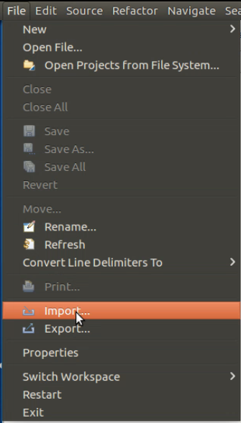 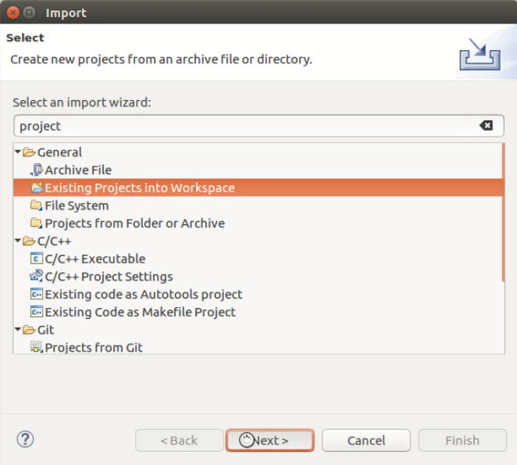

Figure 1 Importing project into *Eclipse* – *File -> Import…*

Figure 2 Importing project into *Eclipse* – Import Wizard

Set the *Select root directory* and select the *build* directory of the catkin workspace – in this example:

* Select root directory = /home/zf/projects/ros_debugging_example/catkin_ws/build

The build directory contains the *.project* file for *Eclipse*.

Setup the rest of the settings as shown in Figure 3 page 15.   
Especially leave the *Copy projects into workspace* unchecked.  
The *Eclipse* project will then use the original source files of the catkin workspace.

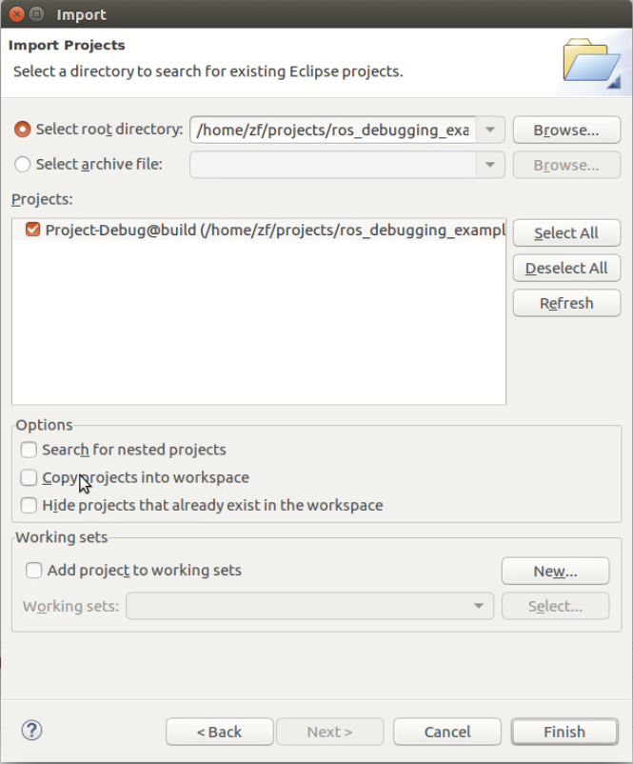

Figure 3 Importing project into *Eclipse* – Import Settings

By default, the project name is “Project-Debug@build”.

After import, the project should be available in the *Project Explorer* Widget, compare Figure 4 page 15.

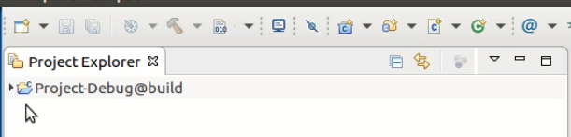

Figure 4 Importing project into *Eclipse* – Project Explorer

## Building the project in *Eclipse*

To check if the setup is correct, try to build the project.  
In the *Project Explorer,* rightclick on the project “Project-Debug@build”.

Then select *Build Project*, compare Figure 5 page 16.

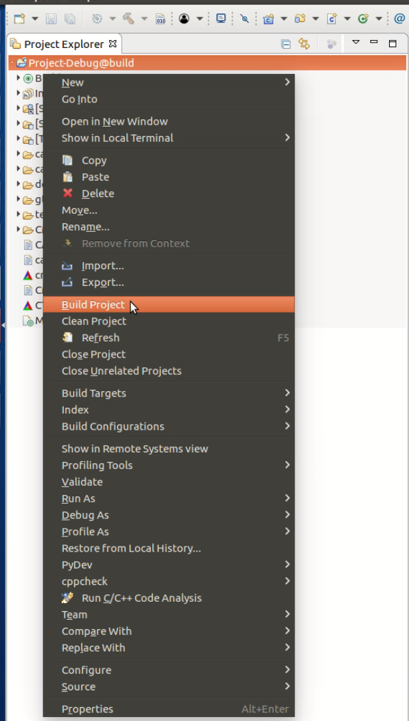

Figure 5 Building the project in *Eclipse* – Project Explorer

The *Console* widget shows information about the build process, compare Figure 6 page 17.  
If everything went correct, the Message “<time stamp> Build finished (took <duration>)” should appear.

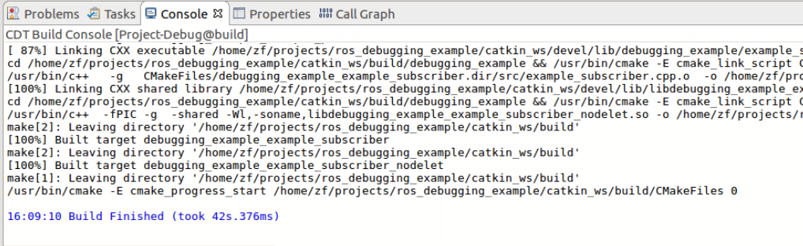

Figure 6 Building the project in *Eclipse* - Console

Now the project can be modified from within Eclipse.

However, any new source file must be registered in the appropriate package-*CMakeLists.txt.*

Any modifications of the registered cpp files can be handled by a rebuilt from within *Eclipse*.

The *Eclipse* project uses the original source files of the catkin workspace.

# Debugging Single Node

Alias: Debugging Local-Single Node by Single-GDB

**[v] Video screencast available…**

After the *catkin* workspace is integrated in *Eclipse* as a project (see chapter 3), different setups of debugging sessions can be setup in *Eclipse*.

This chapter describes how to debug a single *ROS* node with a single *Gnu Debugger* (*gdb*) instance in *Eclipse*.

This debugging setup is appropriate for the following use case:

* Debugging one single node
* No other nodes exist or other nodes are irrelevant (and stable)

## Process Overview

Figure 7 page 18 shows an overview of the debugging setup.

Every process takes place on a local PC.



Figure 7 Diagram – Process Overview - Debugging Single Node by Single-GDB

## Step by Step Setup

This chapter describes a step by step setup for debugging a single *ROS* node in *Eclipse*.

### Terminal Setup in *Eclipse* (optional)

Before the debug configuration is setup, it is helpful to start roscore.

This can be done using a terminal inside *Eclipse*.

*Window -> Show View -> Terminal* allows to open a terminal inside of *Eclipse*, reusing all the environment settings which *Eclipse* is already using, compare Figure 8 page 19.

This means we do not have to source any *setup.bash* and can directly start *roscore* in a terminal of *Eclipse*.

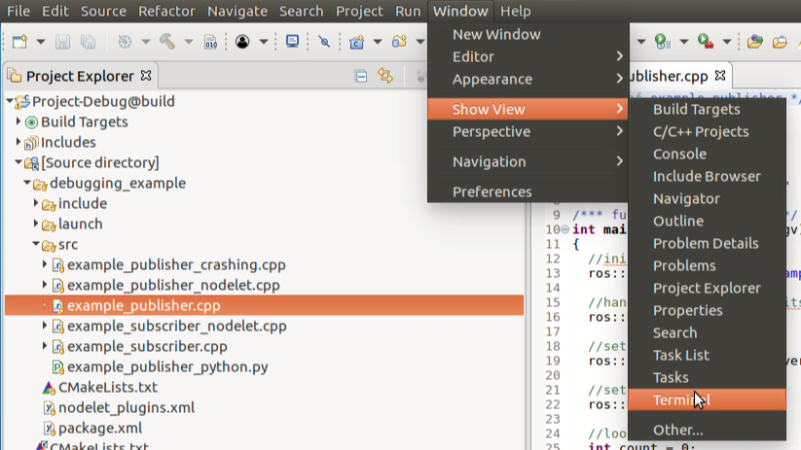

Figure 8 Terminal Setup in *Eclipse* - Window -> Show View -> Terminal

Before we can run any command, we need to initialize the terminal, by clicking on the small Monitor Icon, see Figure 9 page 19.

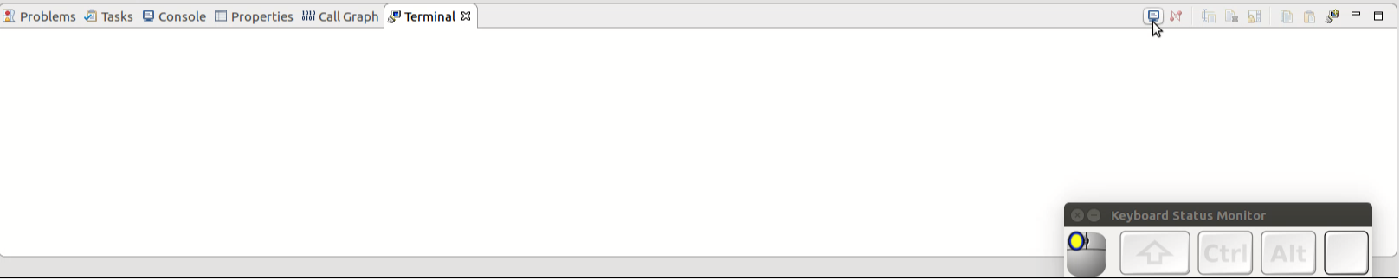

Figure 9 Terminal Setup in *Eclipse* - Initializing a Terminal Window

Thereafter, a window “Launch Terminal” pops up, which should be confirmed with default settings, see Figure 10 page 20.

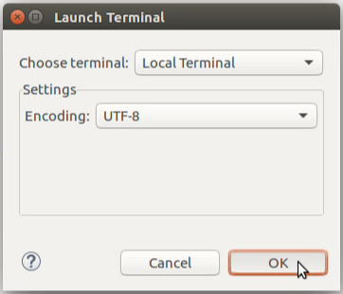

Figure 10 Terminal Setup in *Eclipse* - Launch Terminal

Then, the command “roscore” can be written to start the rosmaster, see Figure 11 page 20 and Figure 12 page 20.

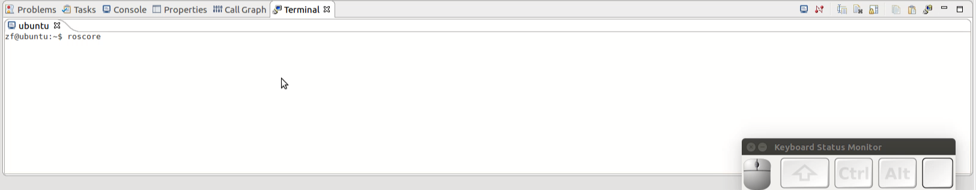

Figure 11 Roscore from within *Eclipse* – Starting Roscore

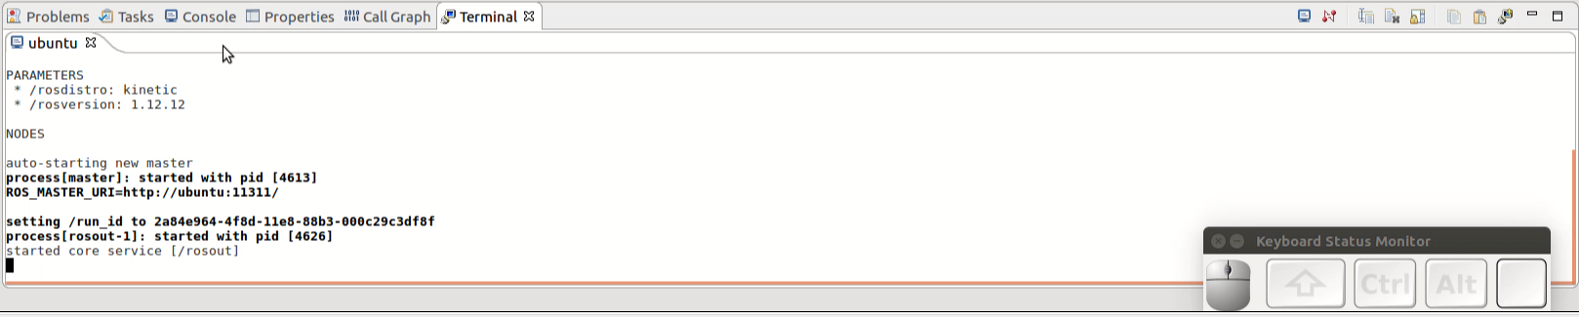

Figure 12 Roscore from within *Eclipse* – Running Rosmaster

Running the *rosmaster* from within *Eclipse* does not have any side effects.

The *rosmaster* may also run from outside of *Eclipse* with an appropriate environment setup.

### Setup Debug Configuration

A new *Eclipse Debug Configuration* can be setup by clicking on the arrow right next to the bug in the menu-list, see Figure 13 page 20.

Then leftclick on *Debug Configurations…,* compare Figure 14 page 21.

Alternatively, you can also access *Run -> Debug Configurations…*



Figure 13 Setup Debug Configuration - (1)

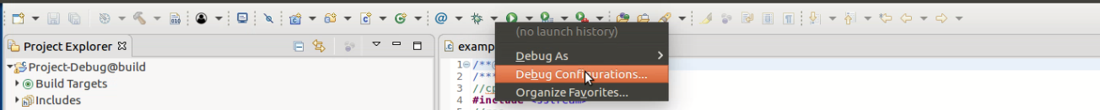

Figure 14 Setup Debug Configuration - Debug -> Debug Configurations...

A separate window with the title *Debug Configurations* should appear.

In this new window, rightclick on *C/C++ Application* and leftclick *New,* compare Figure 15 page 21.

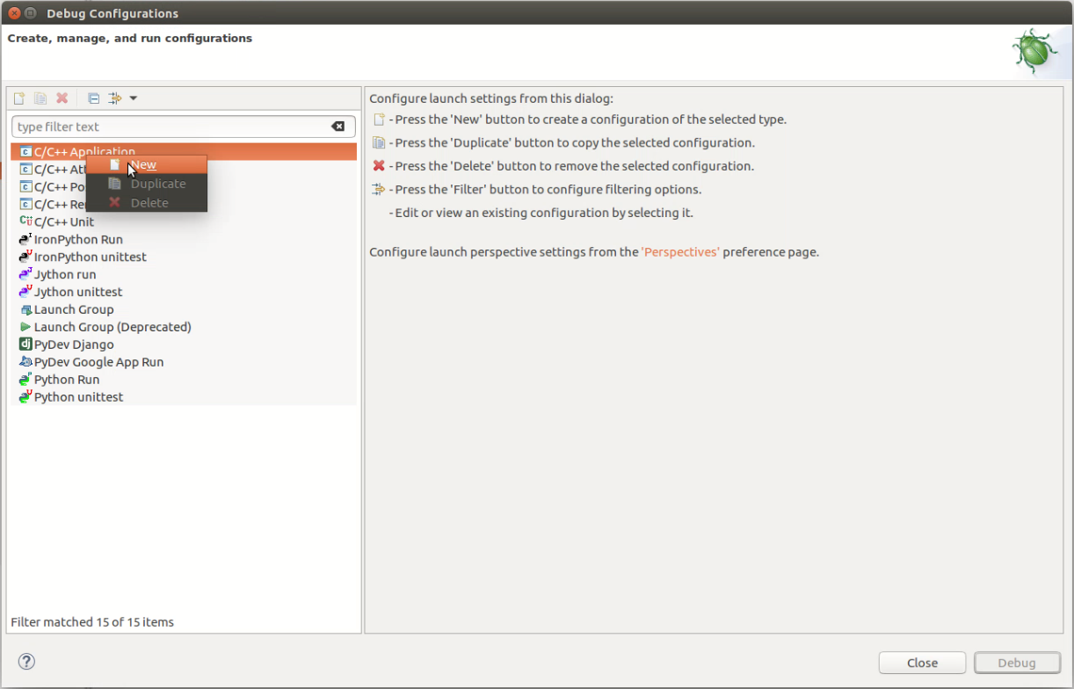

Figure 15 Setup Debug Configuration - Debug Configurations

Figure 16 page 22 shows the setup of the *Main* panel of this debug configuration.

The following actions should be performed:

* Change the *Name* of the debug configuration (optional)
* Set the *C/C++ Application*
  + usually, the path to the application is   
    *<catkin_workspace>/devel/lib/<package_name>/<executable>*
* Press *Apply*

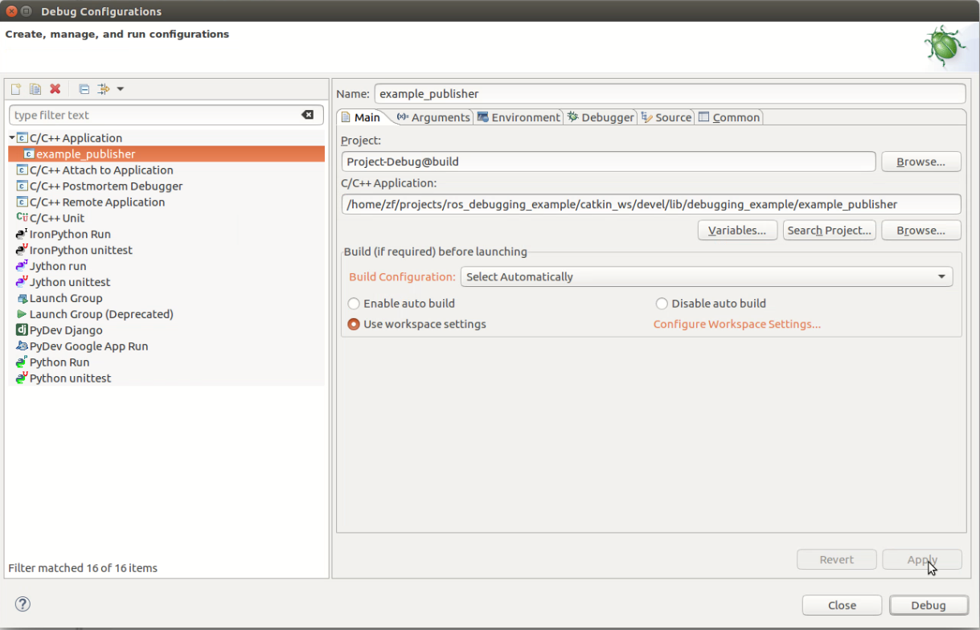

Figure 16 Setup Debug Configuration – Main

If you want to debug your application in *all-stop-mode*, then you are already finished with the debug-configuration and can press the *Debug* button.

For setting up the debug configuration in *non-stop-mode*, see chapter 4.2.5 Debugging in Non-Stop-Mode page 27.

For an explanation and comparison of *all-stop-mode* vs. *non-stop-mode* see chapter 4.3 All-Stop-Mode vs Non-Stop-Mode page 28.

### Starting Debugging

After pressing the *Debug* button, the application is executed.

By default, a function breakpoint is setup on the *main* function (this setting can be configured) and is hit immediately after starting the debug session.  
(Note: other breakpoints can be set by performing right-click🡪 *Add Breakpoint…* or double-left-click on a line-number in a source file*.*)

Confirm to switch into *Debug Perspective, w*hen you are prompted with a popup “Confirm Perspective Switch”, see Figure 17 page 23.

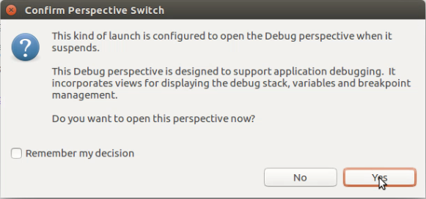

Figure 17 Switching to Debug Perspective

Figure 18 page 23 shows the debug perspective.

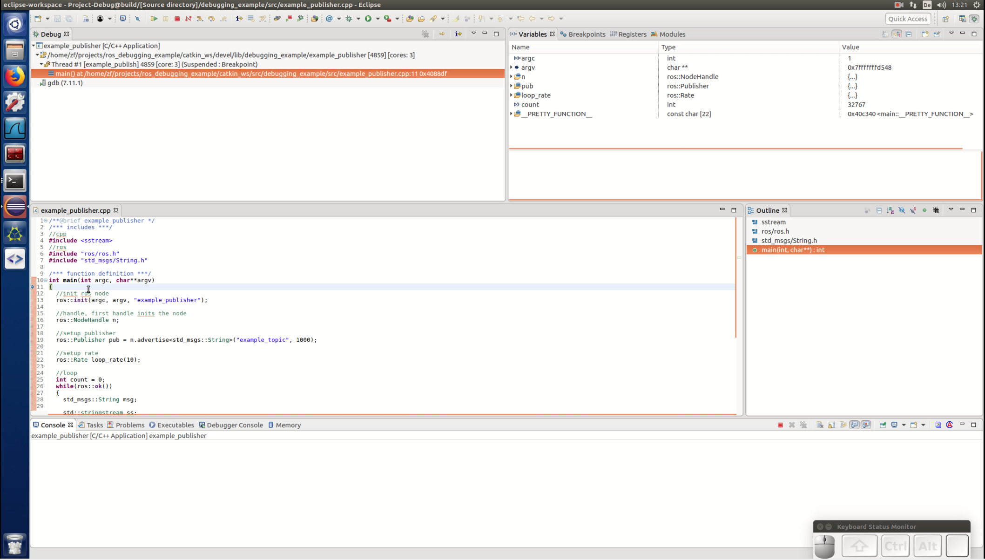

Figure 18 Debug Perspective

A brief overview of different panels/views follows.  
All of these panels can also be individually opened using *Window -> Show View -> ….*

A small blue arrow in the source panel indicates, where the instruction pointer currently points at, see Figure 19 page 24.

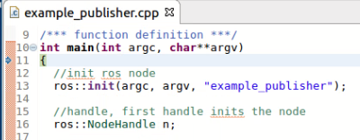

Figure 19 Debugging Session – Source panel - Instruction Pointer

The *Debug* panel shows an overview of all processes, all threads and their backtraces, see Figure 20 page 24.

(“A backtrace is a list of the function calls that are currently active in a thread.”, see <https://www.gnu.org/software/libc/manual/html_node/Backtraces.html> ).

By clicking on the individual threads, you can select the active one, which is controlled by the *Debug Toolbar*.

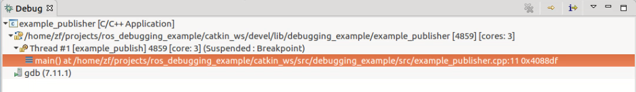

Figure 20 Debugging Session – Debug panel - Overview showing active Process, active Thread and current stack

The *Debug Toolbar* contains buttons for typical debugging instructions like *Step Over, Resume, Break, Stop,* etc*,* see Figure 21 page 24.



Figure 21 Debugging Session - Debug Toolbar

The *Variables* panel shows the local variables of the selected process - thread - function, see Figure 22 page 24.  
(Selection is done in the *Debug* panel by left-clicking on the function/thread/process).

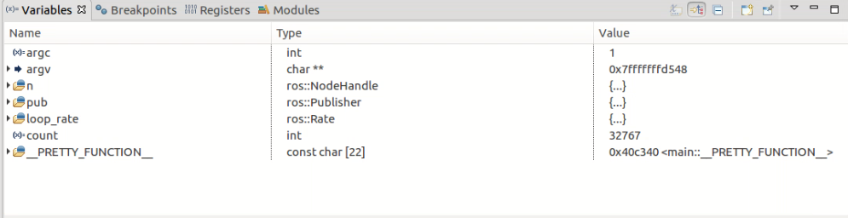

Figure 22 Debugging Session - Variables panel

The *Breakpoint* panel provides an overview about the breakpoints, see Figure 23.

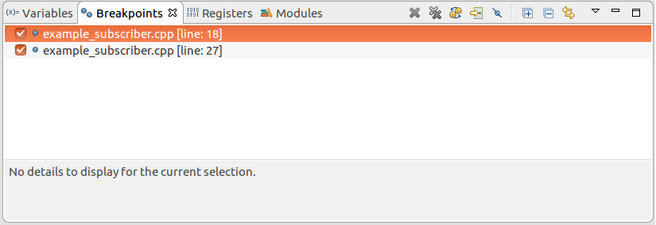

Figure 23 Debugging Session - Breakpoint panel

The recommended setup contains the following views/panels:

* *1. Debug*
  + overview of threads (and processes)
* *2. Variables*
  + Local variables
* *3. Breakpoints*
  + Breakpoint overview
* *4. Source*
  + Source files
* *5. Console*
  + terminal output of process
* *6. Debugger Console*
  + gdb command line interface
* ( *Project Explorer* )
  + Access to other sources

### Debugging in All-Stop Mode

To debug in *all-stop mode*, the flag for *non-stop mode* must not be set in the *Debug Configuration*.

See Figure 24 page 26.

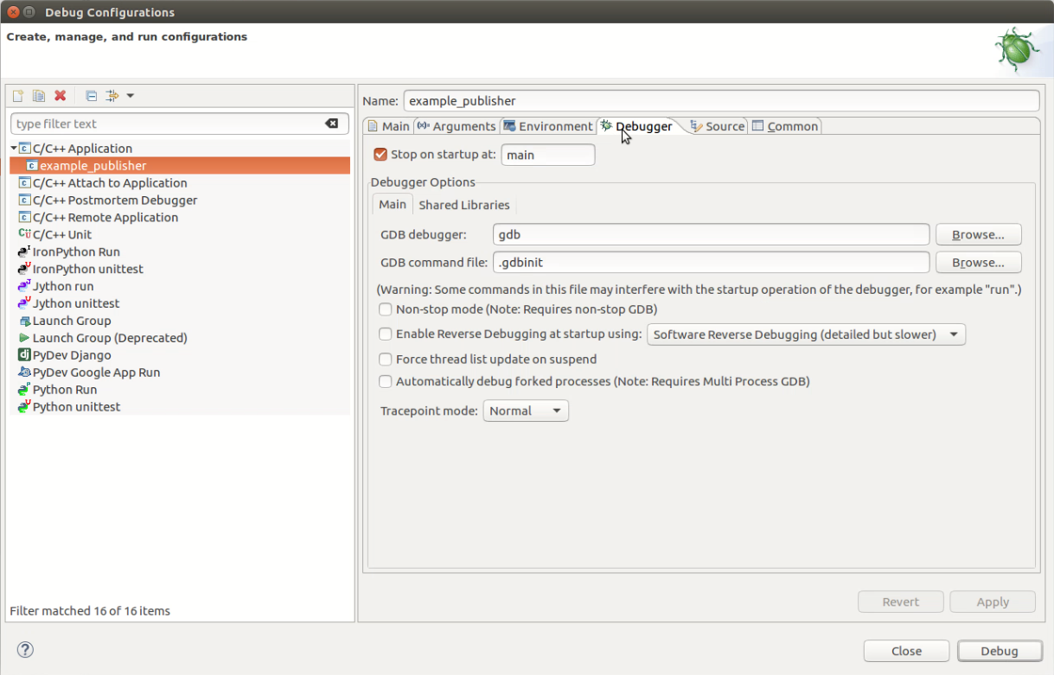

Figure 24 Debug Configuration - Debugger - all-stop mode

When debugging in all-stop-mode, all threads of the current process are either suspended or running.

See Figure 25 page 26.

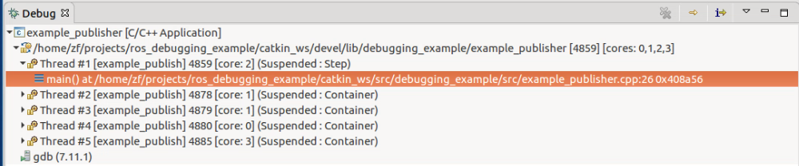

Figure 25 Debugging in all-stop mode

### Debugging in Non-Stop-Mode

To debug in all-stop-mode, the flag for *Non-stop mode* must be set in the Debug Configuration.

See Figure 26 page 27.

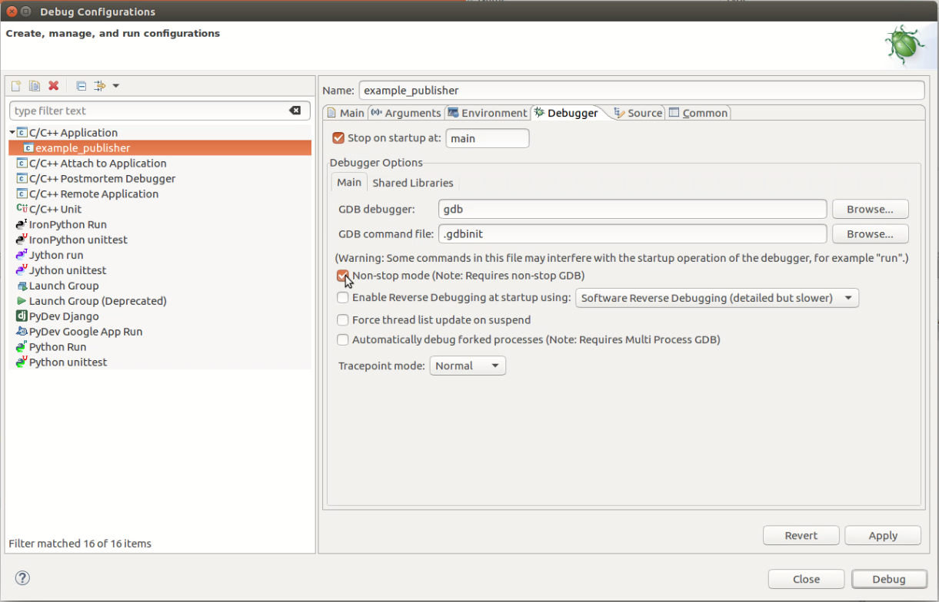

Figure 26 Debug Configuration - Debugger - non-stop mode

When debugging in non-stop mode, you have more control about what threads are suspended and which not.

For example you can step through your main thread while the other threads are running, compare Figure 27 page 27.

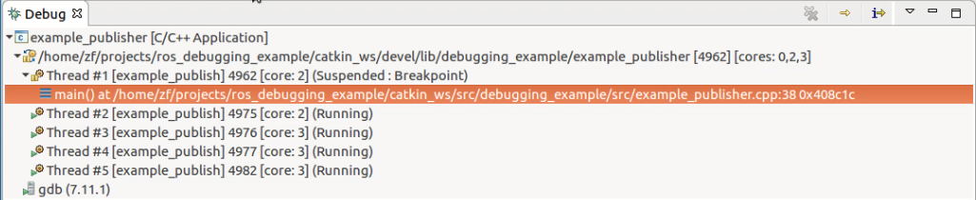

Figure 27 Debugging in non-stop mode

Of course, this induces a higher level of complexity and debugging in all-stop mode may be sufficient in many cases.

## All-Stop-Mode vs Non-Stop-Mode

Basic *ROS* nodes are multi-threaded processes.

The main feature of all-stop mode is, that either all your threads are either running or suspended.

This means, when you step over a line of code, all threads are resumed for a short time.

This time and the associated number of executed low-level instructions, however, might be not deterministic, because the thread scheduling is managed by the operating system and not by the debugger (gdb used by *Eclipse*).

(Some settings can manipulate this behavior – not further discussed here.)

(“In particular, GDB cannot single-step all threads in lockstep. Since thread scheduling is up to your debugging target’s operating system (not controlled by GDB), other threads may execute more than one statement while the current thread completes a single step. Moreover, in general other threads stop in the middle of a statement, rather than at a clean statement boundary, when the program stops.”  
See <https://sourceware.org/gdb/onlinedocs/gdb/All_002dStop-Mode.html#All_002dStop-Mode> for more details).

As mentioned before, this “disadvantage” may not be significant for your debugging session.

Non-stop mode might be more appropriate for your multi-threaded process, since you have more control about which thread is running and which thread is suspended.

This feature is especially useful for *watchdog threads* or *heartbeat threads*, which should not be interrupted.

Basic *ROS* nodes do not have watchdog or heartbeat threads, but they do have a special *communication* thread, which handles for example the network transfer of messages to other nodes, see Figure 28 and Figure 29.  
If this specific thread is not controlled correctly, your message might not get transferred, although you step through the publish function in your main thread.  
This case might theoretically happen, although was not observed by the author in the simple evaluation setup.

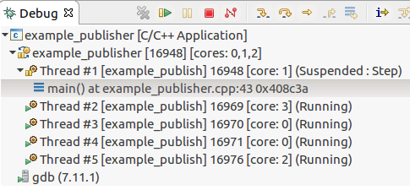

Figure 28 ROS threading (1)



Figure 29 ROS threading (2)

Furthermore, only non-stop mode works for the approach of debugging child-processes of roslaunch, see chapter 5 page 30.  
(All-stop mode has complications for unknown reasons).

Therefore non-stop mode is to be preferred in the roslaunch setup.

# Debugging Multiple Nodes

Alias: Debugging Local Multi-Node System by Single-GDB started by roslaunch

**[v] Video screencast available…**

This chapter describes how to debug all local nodes of a *ROS* system started by roslaunch.

*Eclipse* uses the *Gnu Debugger* (*gdb*) and provides a graphical user interface (GUI).

Several gdb features help to debug multiple nodes at once started by roslaunch.

* one gdb instance can manage multiple processes (called “inferior”)
* one gdb instance can automatically attach to forked processes (child processes)  
  (all nodes started by roslaunch are child processes)
* Multi-process-debugging-features (e.g. interrupting all processes at one breakpoint )   
  can be realized by break commands (see chapter 6 page 39).

Using these features, multiple nodes can be debugged in one single *Eclipse Debug Configuration*.

Note that this setup was evaluated only with few nodes (3-4) and simple launch files.  
For complex launch files with many nodes the described debugging approach might not be suited.

## Process Overview

Figure 30 page 31 shows the process overview of this debugging setup.

All processes must run on the local machine.

Here is a description of what will happen, when the debugging session is started.

*Eclipse* starts gdb.

Gdb starts python with roslaunch as argument (roslaunch is a python script).

Roslaunch starts Node_A and Node_B.

Gdb automatically attaches Node_A and Node_B.

Optionally, if rosmaster is not running yet, roslaunch also starts a rosmaster.

In that case, gdb also attaches the rosmaster.



Figure 30 Diagram – Process Overview - Debugging Multi Node by Single-GDB

## Step by Step Setup

This section describes step by step how to setup a configuration to debug multiple nodes on the local machine started by roslaunch using one single gdb instance in *Eclipse*.

The relation of one single gdb to multiple processes allows multi-process-debugging-features, see section 6 page 39 for further details.

This section is split into multiple parts:

* Node System Description
* Breakpoint Preparations
* Debug Configuration
* Debug Execution

### Example Node System

The example setup used here is very simple.

Figure 31 shows the setup without any debugging configuration.

The setup is very similar to the talker and listener setup of the package roscpp_tutorials.



Figure 31 Example Multi Node Setup using roslaunch

See also the launch file, example_pub_sub.launch.

The launch file does not contain any special debug-modifications and can be used as is in a live system.

<launch>

<!-- based on http://wiki.ros.org/ROS/Tutorials/UsingRqtconsoleRoslaunch -->

<!-- based on http://wiki.ros.org/roslaunch/Tutorials/Roslaunch%20tips%20for%20larger%20projects -->

<!-- debug setup based on http://www.ceh-photo.de/blog/?p=899 -->

<!-- nodelet setup based on http://wiki.ros.org/nodelet/Tutorials/Running%20a%20nodelet -->

<node

pkg="debugging_example"

type="example_publisher"

name="pub"

output="screen"

/>

<node

pkg="debugging_example"

type="example_subscriber"

name="sub"

output="screen"

/>

</launch>

### Breakpoint Preparations

In this debugging approach, there is no automatic stop at the main function of our nodes.

Therefore, we have to setup some breakpoints before (if we want to stop at the main input).

Figure 32 and Figure 33 shows the breakpoint preparation setup used in this example.

Figure – Breakpoint Publisher

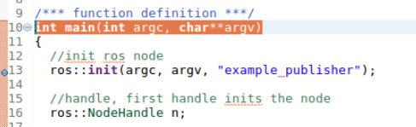

Figure 32 Breakpoint Preparations - example_publisher - Local Multi Node

Figure – Breakpoint Subscriber

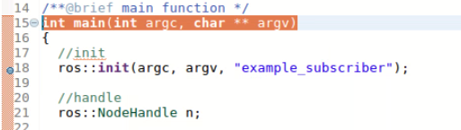

Figure 33 Breakpoint Preparations - example_subscriber - Local Multi Node

### Debug Configuration

This subsection describes, how to configure the debug configuration.

There is only one single debug configuration necessary.  
Open the *Debug Configuration* window using *Run -> Debug Configurations…*, compare Figure 34.

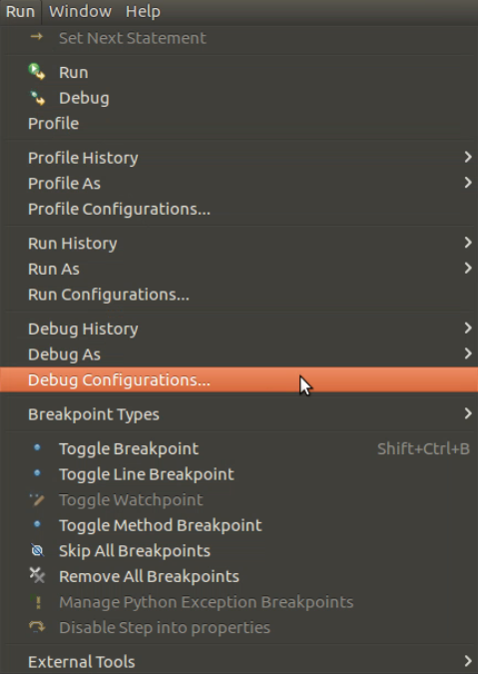

Figure 34 Run -> Debug Configurations...

In the *Main* section of the *Debug Configurations* window the following setting is necessary:

As *C/C++ Application* we have to select */usr/bin/python* instead of *roslaunch*.

The reason is, that *roslaunch* is a python script and gdb/*Eclipse* expects a binary and not a script.

Compare Figure 35.

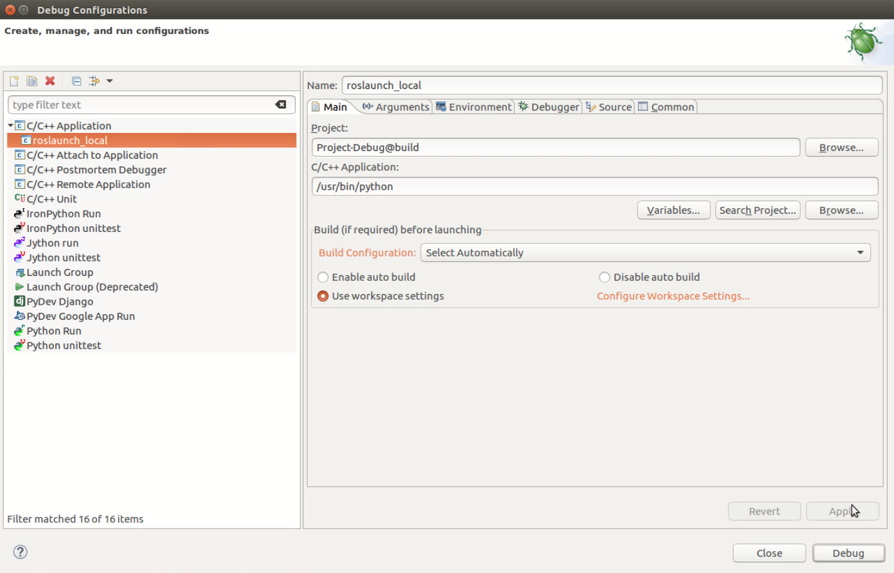

Figure 35 Debug Configuration – Main – Local Multi Node

In the *Arguments* section of the *Debug Configurations* window, we have to mention several arguments:

* */opt/ros/kinetic/roslaunch*
  + The location of the roslaunch file,  
    unfortunately it has to be an absolute file
* *debugging_example* 
  + The package name,  
    no absolute path necessary
* *example_pub_sub.launch*
  + The launch file name,  
    no absolute path necessary

Compare Figure 36.

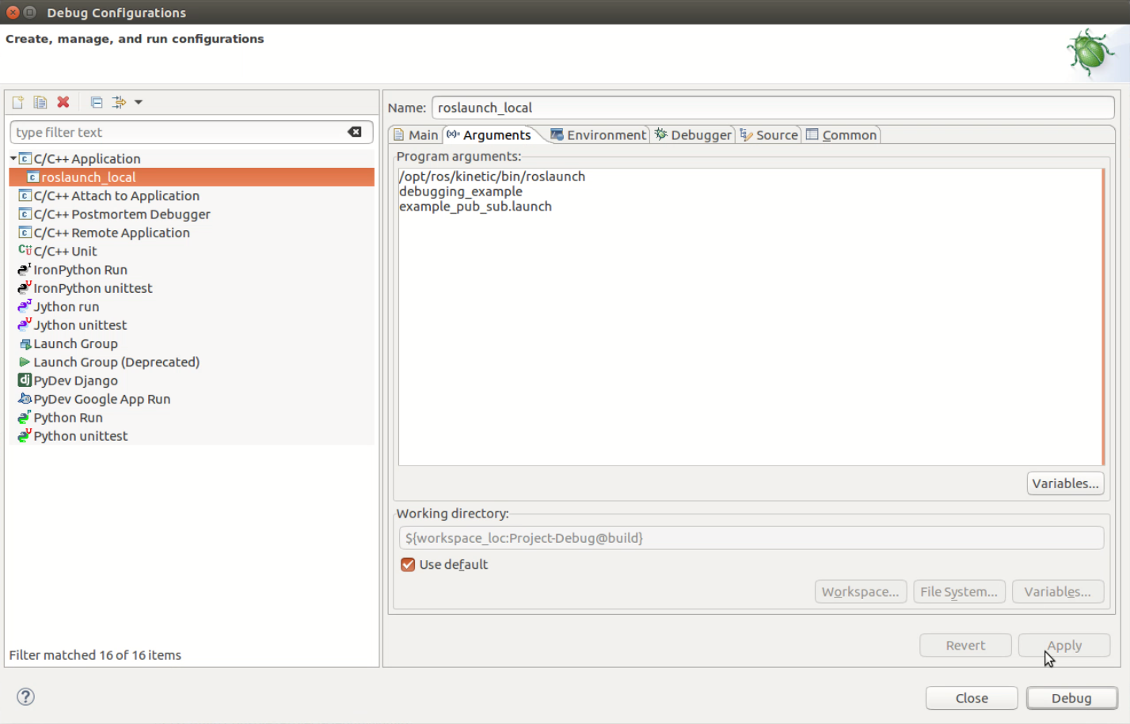

Figure 36 Debug Configuration – Arguments – Local Multi Node

The next important section of the *Debug Configurations* window is the *Debugger* section.

Here, we have to setup two important flags.

* [v] Non-stop mode
  + Debugging forked processes only works in non-stop mode,  
    reasons are unknown
* [v] Automatically debug forked processes
  + This will automatically attach all child processes of python-roslaunch,  
    including our nodes

Compare Figure 37.

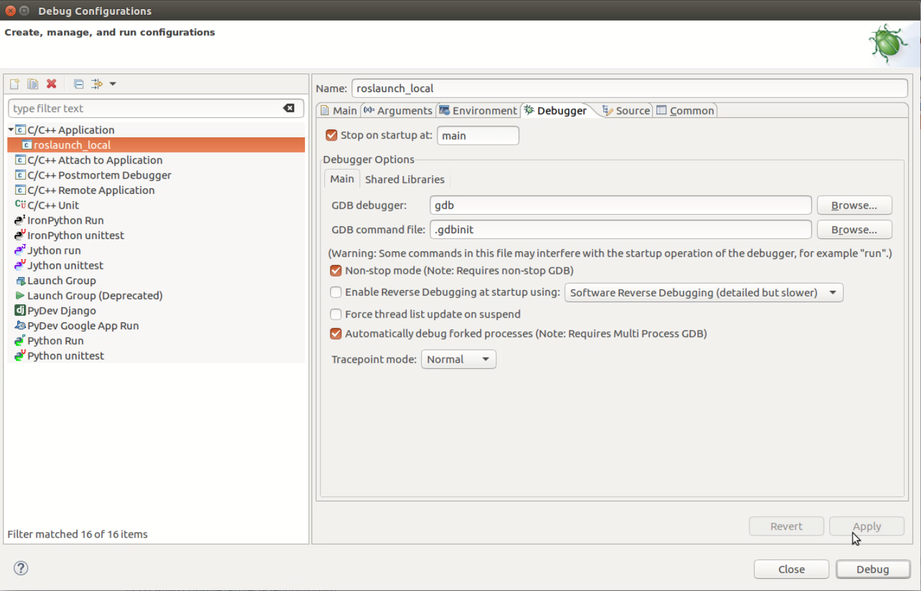

Figure 37 Debug Configuration – Debugger – Local Multi Node

### Debug Execution

After pressing the *Debug* button of the *Debug Configuration* window, we are switching into the *Debug Perspective,* compare Figure 38.

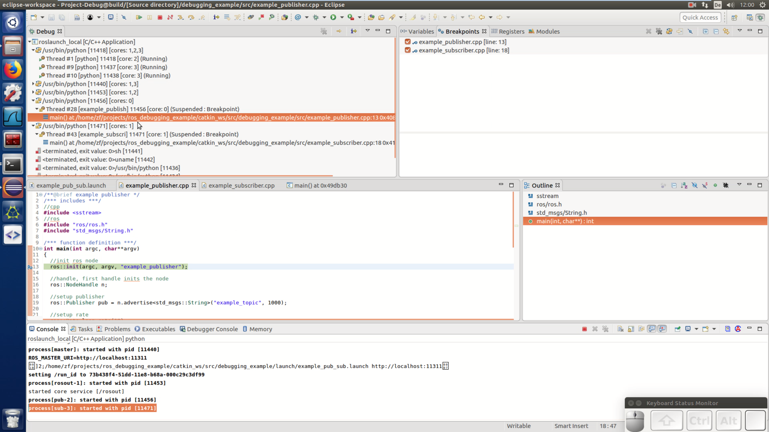

Figure 38 Debug Perspective – Local Multi Node

Figure 39 shows the *Debug* panel of the *Debug Perspective*.

Here, each thread of a process can be selected and managed individually.

It is recommended to open this *Debug* panel as a separate window and use a dedicated display for it alone.

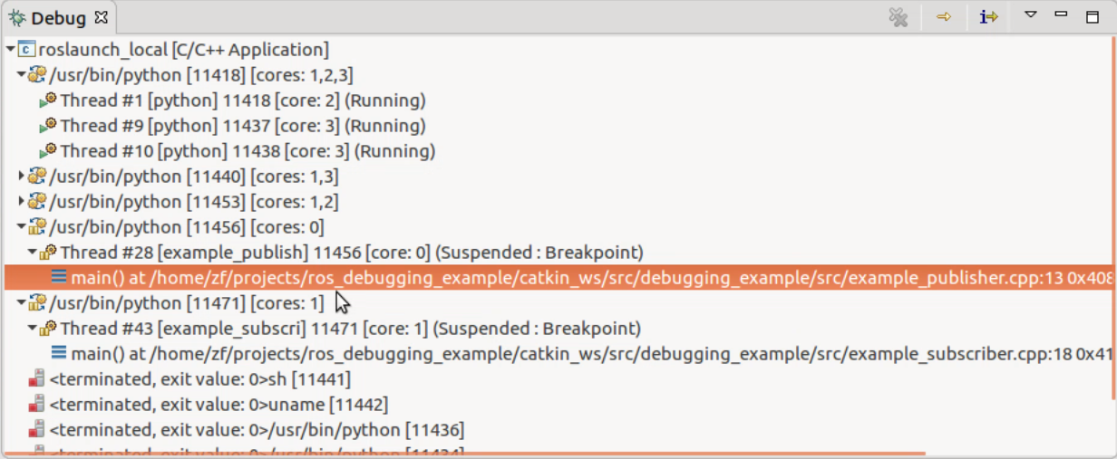

Figure 39 Debug Panel - Thread & Process Overview – Local Multi Node

Multi-Process-Debugging-Features can be realized using “break commands”, see chapter 6.

# Break Commands for Multi-Process-Debugging-Features

**[v] Video screencast-raw available…**

This chapter describes break commands for multi-process-debugging-features.

This chapter is a continuation of chapter 5.

## Overview

Break commands are a feature of *gdb*.

*Gdb* allows to attach a list of commands to a breakpoint.

When the breakpoint is hit, the command list is executed.

For example

* Interrupt all threads of all attached processes
* Interrupt all threads of the current process
* Continue all threads of all attached processes
* Continue all thrads of the current process

*Eclipse* already has a GUI for the setup of break commands and their attachments to breakpoints.

Gdb offers a python API and this python API can also be used to setup complex break commands.

But this topic is out of scope of this document.

## Step by Step Setup

This section describes a step by step setup of break commands in *Eclipse*.

The example setup of chapter 5 is used.

*Eclipse* offers an overview of breakpoints in the *Debug Perspective*, see Figure 40.

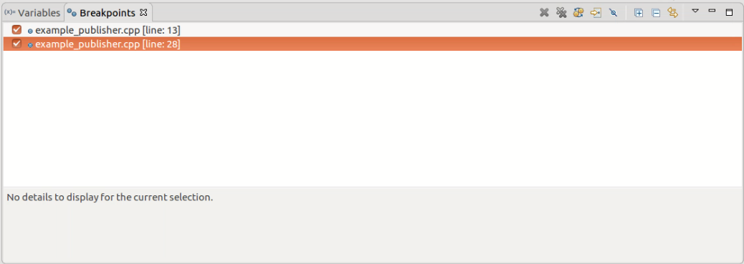

Figure 40 Breakpoint Overview in Debug Perspective

Select the *Breakpoint Properties* of one breakpoint, see Figure 41.

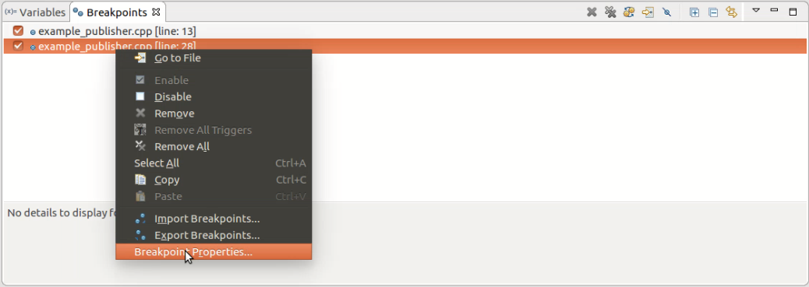

Figure 41 Breakpoint Overview -> Breakpoint Properties...

Figure 42 shows the breakpoint property window.

(In the *Common* section, you can also setup a *Condition* and an *Ignore count*.

See <https://sourceware.org/gdb/onlinedocs/gdb/Conditions.html> for further information.

Use Case for example: only activate the breakpoint, when a local variable has a certain expression.)

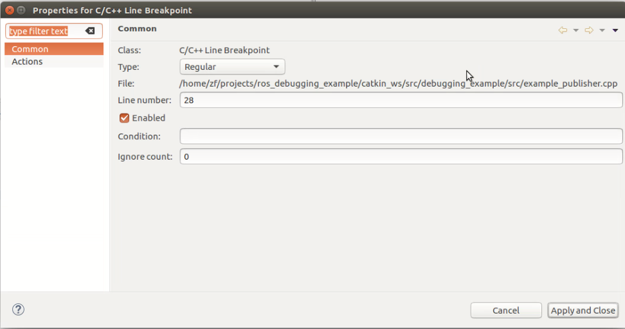

Figure 42 Breakpoint Properties – Common

Switch to *Actions*, see Figure 43 for an empty configuration.

Next, create a new action by clicking the *New…* button.

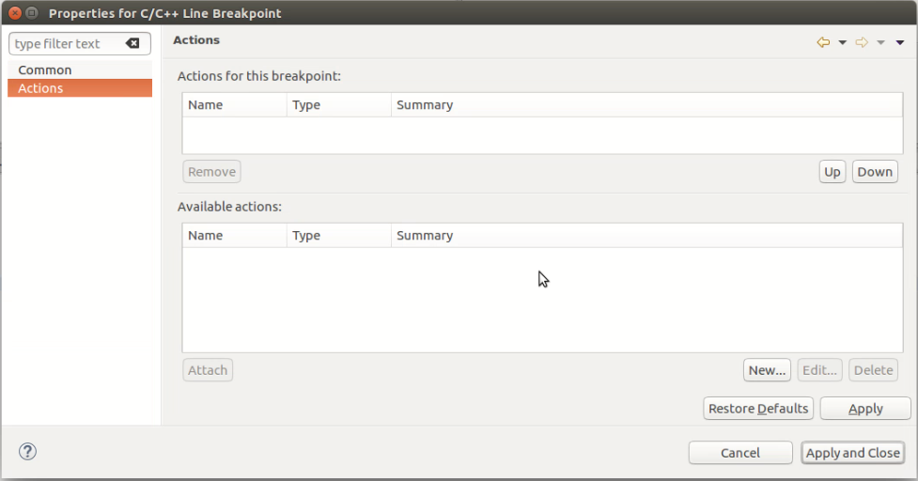

Figure 43 Breakpoint Properties - Actions – Empty

Now, the *New Breakpoint Action* window appears.

Set the *Action type* to *Debugger Command Action*, see Figure 44.

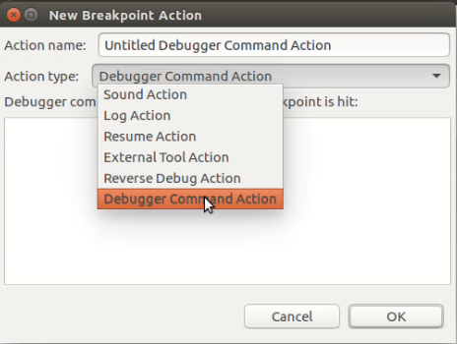

Figure 44 New Breakpoint Action

Now you can specify debugger commands, for example to interrupt all threads of all processes, compare Figure 45.

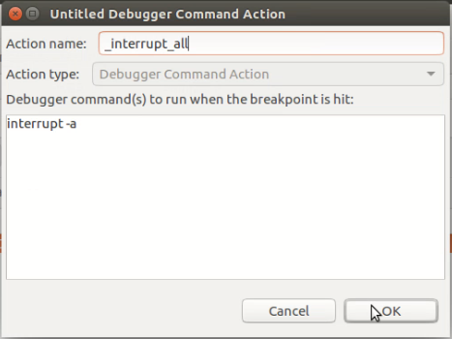

Figure 45 Breakpoint Action - interrupt all

To activate the specified command list for the breakpoint, you have to attach it first!

The final breakpoint property with the attached action is shown in Figure 46.

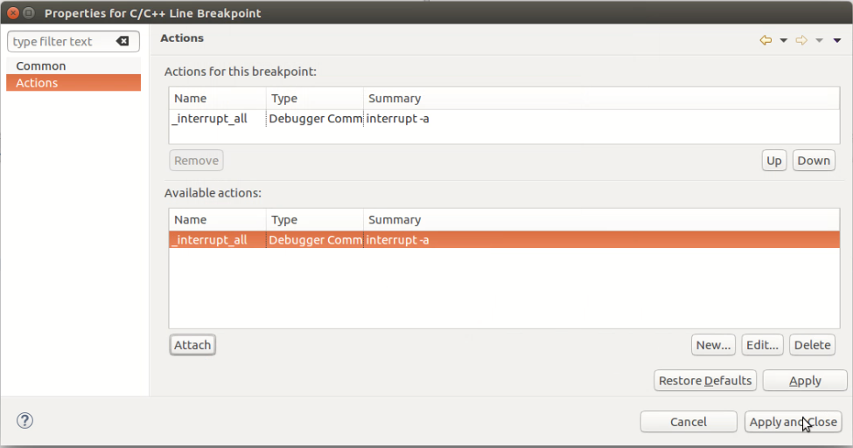

Figure 46 Breakpoint Action attached – interrupt all

Now when the breakpoint is hit, all threads of the attached processes are suspended.

The major inconvenience is, that *Eclipse* automatically expands all threads and shows their backtraces, see Figure 47.

Unfortunately, there is currently no workaround for this inconvenience.

(You can manually collapse all processes again by clicking the small arrow left next to the parent debug configuration).

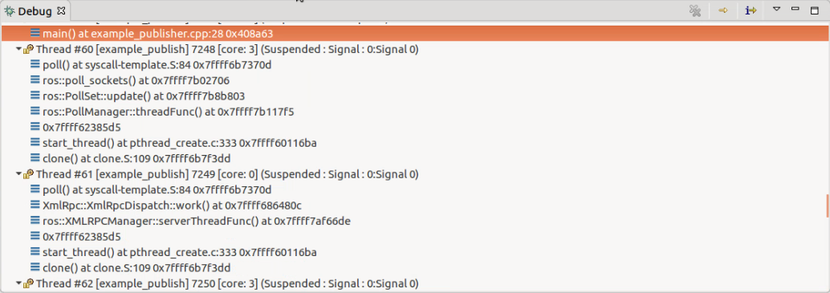

Figure 47 Breakpoint Action - interrupt all - Effect on Debug Overview

To resume all threads, you could select all processes (SHIFT + leftclick) and resume them manually by shortcut (F8) or by rightclick and then clicking on *Resume…*.

Another possibility to resume all threads is to setup another breakpoint, which continues all threads on hit.

This breakpoint could be set at the end of the interesting code section of a loop.

Such a breakpoint setup is summarized in Figure 48.

Note that such a “continue all” breakpoint is also resuming the thread, which triggers the breakpoint.

The easiest way to not continue the triggering thread is to set another breakpoint after the “continue all” breakpoint.

See following pseudo listing:

Breakpoint 1: interrupt all

… step over code

… ordinary breakpoints (no break commands necessary)

Breakpoint 2: continue all

Breakpoint 3: optional, interrupt current thread (no break command necessary)

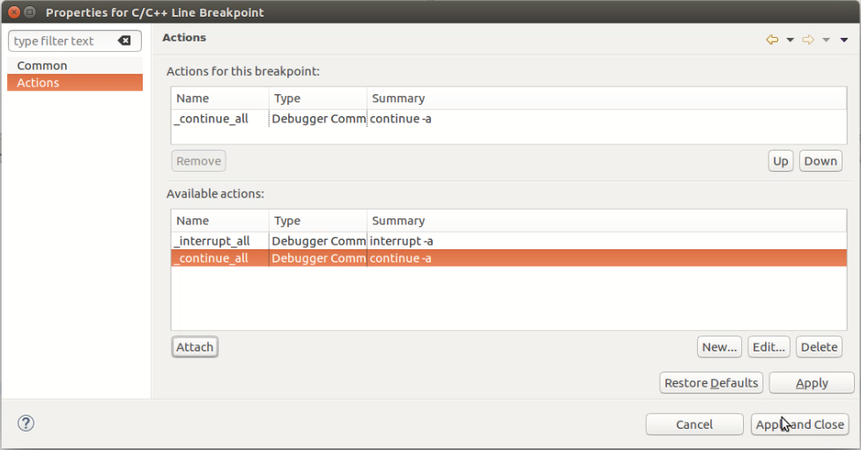

Figure 48 Breakpoint Action attached - continue all

Finally, here are some useful break commands.

(It is considered to setup a default list of available actions in the future.)

#interrupt all threads of all attached processes

interrupt -a

#continue all threads of all attached processes

continue -a

#interrupt/continue all threads of specific process (‘inferior’ = process managed by gdb)

#get information about inferior ids using Eclipse Debugger Console “info inferior”

thread apply <SPECIFIC_INFERIOR_ID>.* interrupt

thread apply <SPECIFIC_INFERIOR_ID>.* continue

#interrupt/continue specific threads

#get information about thread ids using Eclipse Debugger Console “info threads”

#example thread id: 7.8

#example thread id list (ids separated by whitespace): 7.8 8.9 10.6-10

thread apply <LIST_OF_SPECIFIC_THREAD_IDS> interrupt

thread apply <LIST_OF_SPECIFIC_THREAD_IDS> continue

## Break Command Delay Measurements

One major concern was, that there could be a significant time delay when the breakpoint of one thread is hit and when the other threads are suspended due to the break command.

The existence of delay was verified and measured.

See chapter 8.4 about the details of measurement.

The time difference between hitting the break point and interrupting other threads is about 100 ms – 300 ms.  
During this time, the other threads continue execution.

# Core Files for Post-Mortem Analysis

**[v] Video screencast-raw available…**

## What are Core Files? – Use Case

Core files are snapshots of the memory of a process.

Such snapshots can be especially useful if generated when a program crashes.

A core file can then be analyzed.

Under certain conditions, it can be analyzed where exactly the application crashed.

One use case of core file generation and analysis could be, if an application crash occurs only very seldom and the means to reproduce the crash are unclear.

Note that other than in the following example, it may not always be clear from a core file, how and why the application crashed.

(For example when the call stack is corrupted and the backtrace can not be retrieved.)

## System Setup for Core File Generation

Core Files are not generated by default.

The following to commands have to be executed.

The fist command unlimits the core file size.

The second command sets the core file name pattern.

Commands to enable core file generation:

#set core file size to unlimited (default = 0, prevents core file generation)

#view ulimit settings with “ulimit –a”

ulimit –c unlimited

#set core file pattern

#view core file pattern with “head /proc/sys/kernel/core_pattern”

sudo sh -c "echo 'core.%e.%p.%h.%t' > /proc/sys/kernel/core_pattern"

Following options for the core file pattern shall be mentioned here:

(see <https://sigquit.wordpress.com/2009/03/13/the-core-pattern/> for more information about pattern).

%p: pid

%: '%' is dropped

%%: output one '%'

%u: uid

%g: gid

%s: signal number

%t: UNIX time of dump

%h: hostname

%e: executable filename

%: both are dropped

Figure 49 shows the terminal output of the command execution and also the original settings.

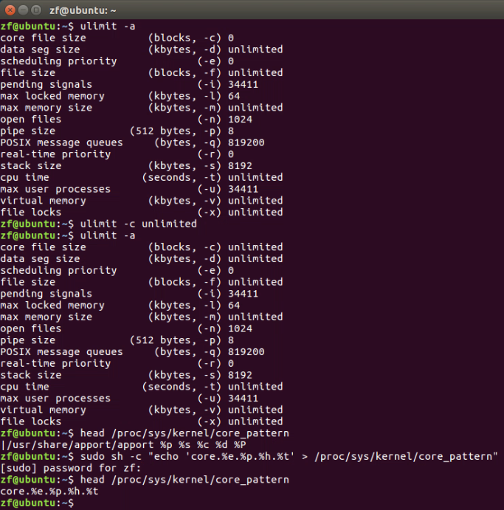

Figure 49 Terminal Output - Enabling Core File Generation

## Generating a Core File – Launching bugged Application

The example application *example_publisher_crashing* generates a segmentation fault inside a function.

This application is just a modified version of *example_publisher* of package *debugging_example* (similar to *talker* of *roscpp_tutorials*).

Following listing shows the commands to start the bugged application and generate a core file.

#source setup.bash files

source /opt/ros/kinetic/setup.bash

source ~/projects/ros_debugging_example/catkin_ws/devel/setup.bash

#execute launchfile with bugged/crashing node

roslaunch debugging_example example_pub_sub_crashing.launch

Figure 50 shows the execution of previously mentioned commands in a terminal.

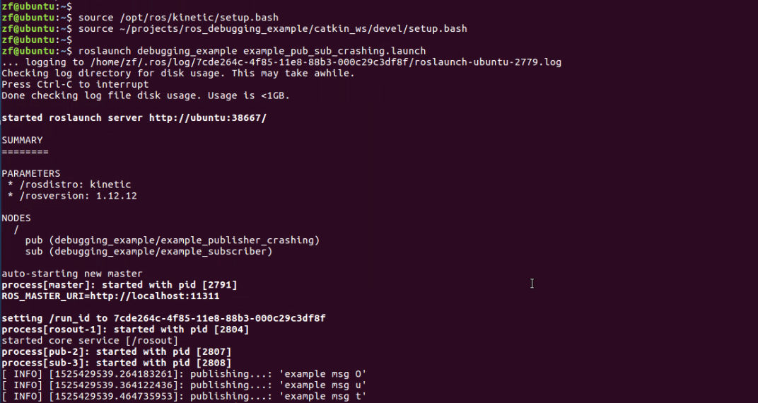

Figure 50 Terminal Output - Starting launchfile with bugged node

When node crashes, core file is written into ~/.ros directory with specified pattern.

Compare Figure 51.

The pid of the crashed application is 2807.

The core file “core.example_publish.2807.ubuntu.1525429543” is generated.

Unfortunately, the full name of the application is not written in the core file name.

*example_publish* is used instead of *example_publisher_crashing*.

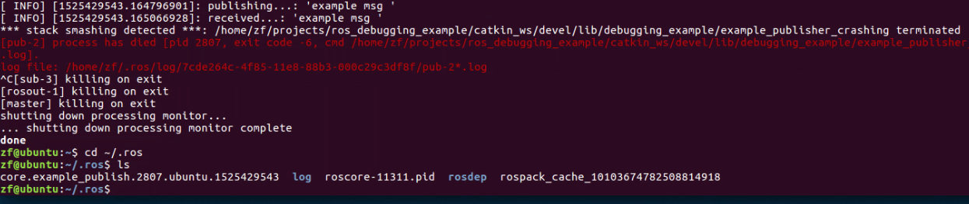

Figure 51 Terminal Output - bugged node crashes and generates core file

## Analysis of Core File in *Eclipse*

To analyse the generated core file in *Eclipse*, setup a debug configuration like specified in Figure 52.

The application, which generated core file must be known (example_publisher_crashing).

(Unfortunately, here, the name of the application is clamped in the core file name).

Select the core file, located in ~/.ros, a hidden directory in the home directory.

Then start the debugging session by pressing the *Debug* button.

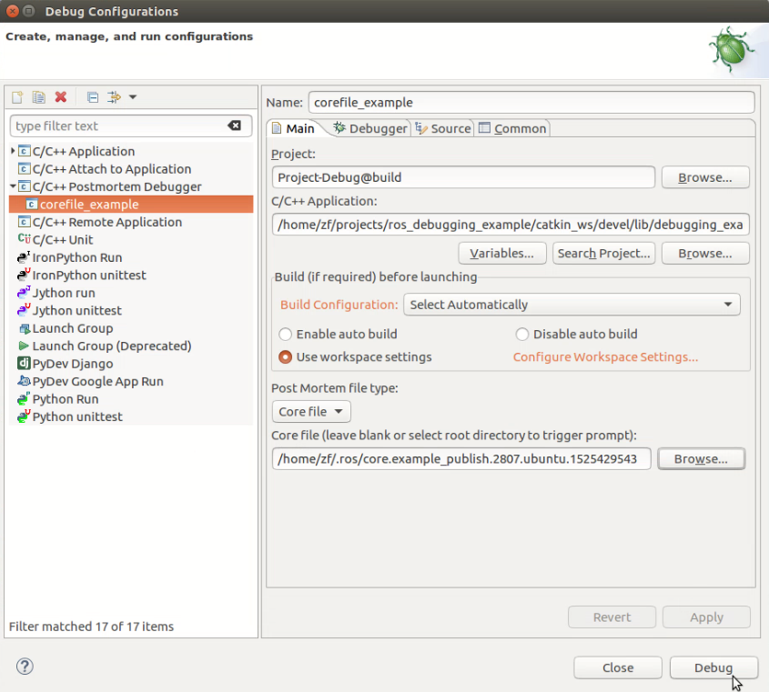

Figure 52 Debug Configuration - Core File Analyse

The already familiar *Debug Perspective* appears, see Figure 53.

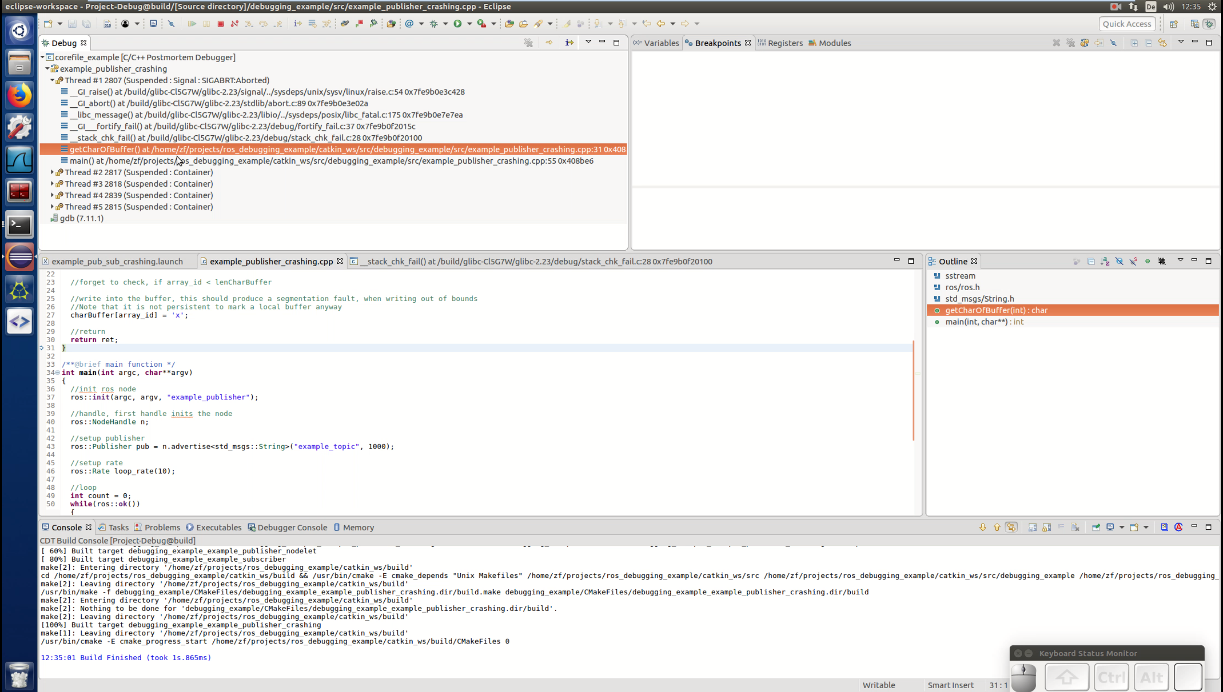

Figure 53 Core File Analyse - Debug Perspective

In the *Debug* panel, the backtrace of all threads at the moment of the segmentation fault can be viewed, see Figure 54.

Note that this is a snapshot and there is no possibility to execute common debugging commands like *resume, suspend, step over*.

In this example, the function which generates the segmentation fault is *getCharOfBuffer*.

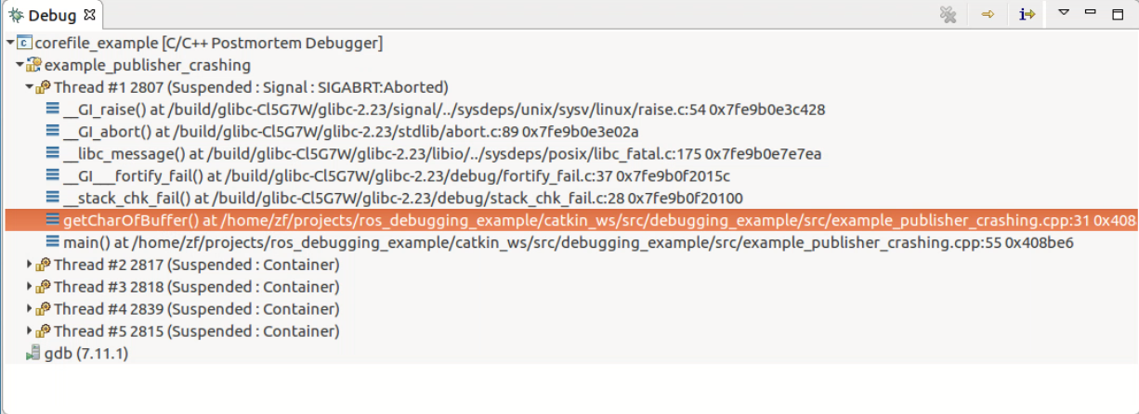

Figure 54 Core File Analyse – Debug panel - backtrace

The *Source* panel indicates the instruction pointer of the snapshot, see Figure 55.

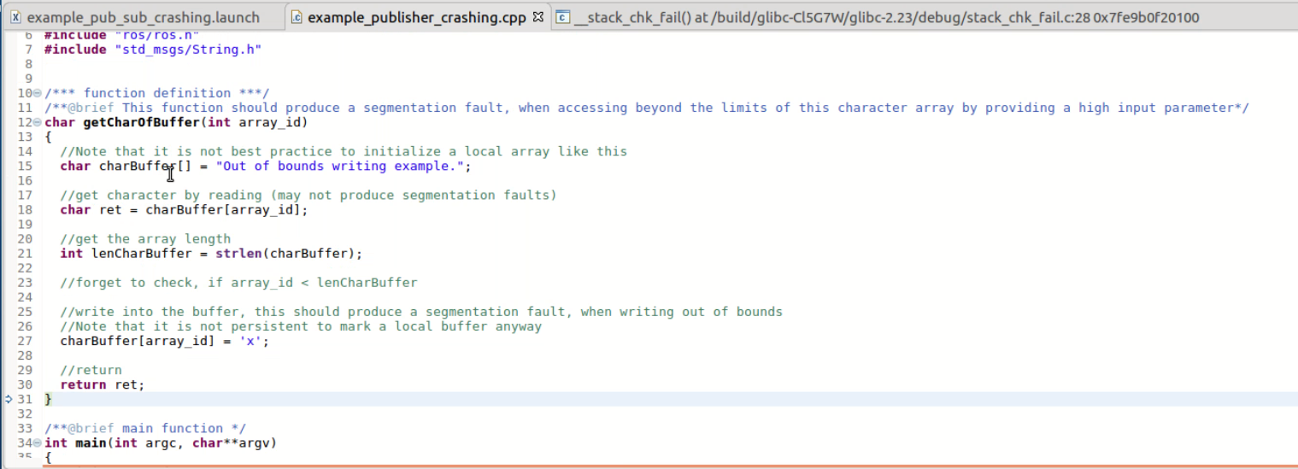

Figure 55 Core File Analyse - Instruction Pointer (blu-white arrow)

The problem of the application may be visible in the *Variables* panel, see Figure 56.

In this example application, the value of the variable *lenCharBuffer* (30) is lower as the value of the variable *array_id* (40), which finally leads to the segmentation fault (writing out of bounds).

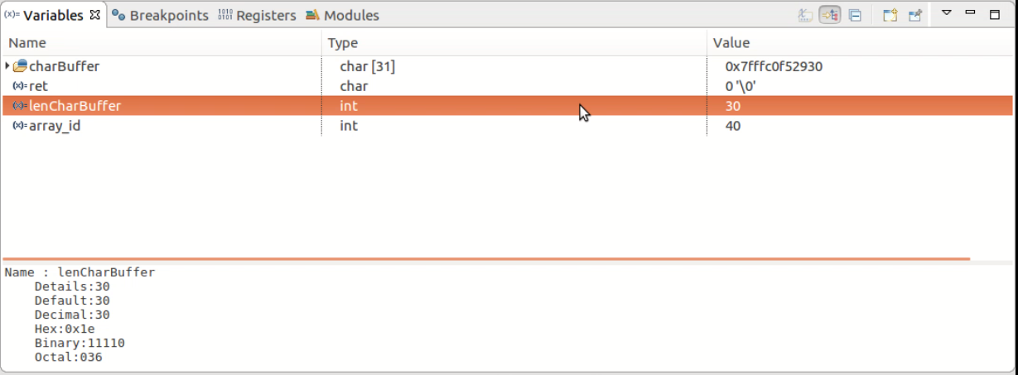

Figure 56 Core File Analyse - Local Variables

# Appendix

## Debugging Nodelets

Alias: Debugging Local Multi-Nodelets Single-Nodelet-Manager by Single-GDB

**[v] Video screencast-raw available…**

Nodelets are not executables but libraries (under linux called shared objects with file ending “.so”).

Multiple possibilities for their debugging in *Eclipse* (gdb) exist:

* Debugging complete roslaunch node graph
  + recommended: reason: simple setup
  + same approach as roslaunch setup, see chapter 5
  + **[v] Video screencast-raw available…**
  + compare Figure 57
* Debugging using nodelet executable + *Eclipse* *External Tool Launch* for loading nodelet
  + not recommended, reason: complex setup
  + **[v] Video screencast-raw available…**
  + compare Figure 58
* Debugging using roslaunch launch-prefix with gdbserver
  + not recommended, reason: complex setup + gdbserver (slow)
  + same approach as multi-machine setup, see chapter 8.2
  + **[v] Video screencast-raw available…**
  + compare Figure 59

Although screencasts for all possibilities exist, only the roslaunch approach is recommended.

The other approaches require a more complex debug configuration without any significant advantage.

Due to the similarity to the roslaunch approach with chapter 5, a step by step setup will not be provided here.

### Process Overview

This section contains the process overview of different nodelets debugging setups.



Figure 57 Process Overview - Nodelets - roslaunch forked processes



Figure 58 Process Overview - Nodelets - Standalone

(gdbserver approach – should also be possible as a remote setup – using gdbserver) 

Figure 59 Process Overview - Nodelets - gdbserver

## Debugging Multiple Nodes (remote)

Alias: Debugging Remote Multi-Node System by Multi-GDB (roslaunch)

**[ ] Video screencast-raw available…** (see similar: screencast nodelets – gdbserver)

This approach is not recommended.

The setup is complex and no multi-process-debugging-features are possible.

The approach shall still be mentioned here, since it is also foreshadowed in the roswiki,   
see <http://wiki.ros.org/roslaunch/Tutorials/Roslaunch%20Nodes%20in%20Valgrind%20or%20GDB> .

With this approach, multiple nodes can be started with multiple gdb-gdbserver connections.

The key to this approach is to use a *gdbserver* in the *launch-prefix* attribute of the launch file.

This means the launch file must be manipulated.

However, the approach described in chapter 5 is simpler and allows multi-process-debugging-features.

Also, the launch file requires no manipulation.

The disadvantage of approach of chapter 5 is, that it only works with nodes on the local machine.

Gdb and *Eclipse* is currently not able to attach to multiple processes on different machines.

Following list shows the features of current gdb versions (7.11 and 8.1)

* [v] multi-thread
* [v] multi-process
* [ ] multi-machine

One possible advantage of the approach described in this chapter could have been the availability of the tracing feature of gdb, since the tracing feature only works with a gdbserver.

However, the tracing feature of gdb has currently too many limitations (i.e. only works with gdbserver) and tracing alternatives (i.e. ROS_LOG) are to be preferred.

Regarding tracing/logging see also chapter 8.3.6.

### Process Overview

Figure 60 shows the process overview of this debugging configuration.

*Eclipse* starts roslaunch as an *External Tool Launch*.

Roslaunch starts the nodes on the remote machine with using gdbserver as a launch prefix.

The gdbservers manage the remote nodes.

*Eclipse* also starts multiple gdb instances, which connect to the gdbservers on the remote machine.

For each gdb connection one *Eclipse Debug Configuration* needs to be configured.



Figure 60 Process Overview - Multi Node Multi Machine Debugging Setup

## Non-Focus

This section provides an overview of side-topics, which will not be described closer in this document due to limited significance, limited application or very high complexity (outweighing the benefits).

### *ROS* analyse tools

Some ROS analyse tools shall be mentioned in the following list

* rqt_console
  + <http://wiki.ros.org/rqt_console>
  + shows ROS_LOG information
* roswtf
  + <http://wiki.ros.org/roswtf>
  + checks *ROS* setup for errors and problems
* rqt Topic Monitor
  + <http://wiki.ros.org/rqt/Plugins#Group:_Topics>
  + rqt -> Plugins -> Topics -> Topic Monitor
  + shows all available topics

### Alternatives to *Eclipse* and GDB

Alternatives to gdb and *Eclipse* shall only be mentioned here and are not the focus of this document.

*Eclipse* alternatives:

* Roboware
* Qtcreator
* gdb command line
* DDD

Gdb alternatives

* TotalView (*rogueware*) (commercial debugger)
* DDT (*allinea*) (commercial debugger) (focus: HPCs and parallel applications)

### Python Debugging

Different approaches exist, among others, the following shall be mentioned:

* Pydev (*Eclipse*)
  + recommended
  + allows stepping through
* Gdb with python extension (command line)

Use Cases:

* Single Node (indepenant)
* Only Python

### GDB Feature – Reverse Debugging

The feature “Reverse Debugging” of gdb shall only be mentioned here.  
This feature allows to *step backwards* in code.

However, this topic in relation to *ROS* applications is too unclear at the moment and is not recommended.

*ROS* is very network-dependent, many OS-socket buffers are to be considered when stepping backwards – e.g. un-receiving a *ROS* message may break everything.

<https://sourceware.org/gdb/current/onlinedocs/gdb/Reverse-Execution.html#Reverse-Execution>

“Some targets may be able undo things like device I/O, and some may not”.

### Valgrind

Valgrind is a complex tool and offers many functionalities, which will not be reviewed here.

Functionalities among others:

* Finds uninitialized values
* Finds memory access that should not be accessed
* Finds invalid freeing of memory
* Finds data races
* Finds memory leaks

Valgrind is a command line tool and can be started with:

* valgrind ./myApplication

The application will run considerably slower (about 20 times slower).

Further information to Valgrind

* <http://maintainablecode.logdown.com/posts/245425-valgrind-is-not-a-leak-checker>
* <http://valgrind.org/docs/manual/manual.html>

### Tracing / Logging

Tracing and Logging are important techniques, but are not the focus of this document.

Still some aspects shall be mentioned in this chapter.

Further, an example application of tracing is shown in chapter 8.4.

**What is Tracing and Logging?**

Good explanation about tracing and logging is provided by the following link:

* <https://wiki.eclipse.org/Linux_Tools_Project/LTTng2/User_Guide#About_Tracing>
* <https://lttng.org/docs/v2.10/#doc-what-is-tracing>

The following lists shall summarize the differences:

Tracing

* Troubleshooting technique
* Collecting information on its execution path
* Main Use Case:
  + Record many frequent low-level events at high rate
  + Events E.g.
    - Events from the operating system kernel (system call entry/exit, network activity, …)
    - Application events (UST - User Space Tracing)

Logging

* Similar to tracing
* Main Use Case:
  + High-level analysis of less frequent events
  + Events E.g.
    - User Accesses
    - Exceptional Conditions (Errors, Warnings)
    - Database transactions

**Tracing vs *Stepping through Code***

The floowing listings shall briefly compare tracing to the technique of “Stepping through Code”.

Advantages/Disadvantages of Tracing / Logging

* (+) Non-intrusive
  + real time system analyse
* (+) usable for many nodes on multiple machines
  + Combining trace logs in post processing
* (+) timing bugs
* (-) stepping through code
* (-) static tracepoints require code recompilation
* (-) higher resource usage
  + Trace information needs to be sent, received, saved to disk, etc.
* (--) complex setup

Advantages/Disadvantages of *Stepping through code*

* (-) intrusive
  + no real time system analyse
* (-) very hard to debug many processes at once
  + No comfortable UI to view multiple processes in *Eclipse*
* (-) multi-process-debugging-setup only for local machine
* (-) timing issues are hidden
* (+) stepping through code
* (++) easy setup

**Tracing Tools Overview and Comparison**

Some tracing tools shall discussed here.

* gdb tracepoints (*Eclipse* support)
* *ROS* logging
* LTTng (linux tracing toolkit next generation) (*Eclipse* support)

Many other tracing alternatives exist.

Alternatives are listed in the following links:

* <https://lttng.org/docs/v2.10/#doc-lttng-alternatives>
* <http://dmct.dorsal.polymtl.ca/sites/dmct.dorsal.polymtl.ca/files/Presentation.pdf>

gdb-tracepoints

* (---) only usable with gdbserver
  + Not supported with normal gdb
* (---) no time stamps
* (-) tracing buffer size limitation
* (-) not supported in gdb python api
* (-) executable must be available
* (+) no code modification required
* (+) no recompilation required
  + Dynamic tracepoints
* (+) *Eclipse* post mortem analyse
  + (-) limited functionality
  + (-) no support for multi-process tracing  
     (unclear if gdb supports multi-process tracing)
* (+) data collected can include registers, local variables, global data

*ROS* logging and topic recording

* (-) main use case is “logging”
* (-) analyse/view tools (?)
  + rqt_bag insufficient
  + rqt_console limited visualization
* (-) code modification required
* (-) recompilation required
  + Static tracepoints
* (+/-) dependency on *ROS*
* (+) automatic time stamps
* (+) multi process tracing/logging
* (+) multi machine tracing/logging

LTTng (linux tracing toolkit next generation)

* (-) dependency on lttng
  + Only available on linux -> not portable
* (-) code modification required
* (-) recompilation required
  + Static tracepoints
* (+) automatic time stamps
* (+) multi process tracing/logging
* (+) multi machine tracing/logging
* (+) main use case is “tracing”
* (++) analyse/viewer tools available
  + Lttng fully supported in *Eclipse*

Lttng and *ROS* logging are very similar.

The main difference is the use case and the availability of analyse tools.

At the moment, introducing lttng into the general workflow is not recommended due to massive increase of complexity and the similarity to ROS_LOG.   
Many use cases of tracing/logging can be satisfied using ROS_LOG instead of lttng.

## Measuring the Break Command Delay using Tracing with lttng

**[v] Video screencast-raw available…**

This chapter is still in progress…

Disadvantage:

* Increased complexity
* Code must be adjusted
  + Tracepoints are setup in code
  + Additional libraries have to be linked
* 2 additional threads are generated at application start
* Lttng not portable to windows

Installation based on: <https://lttng.org/docs/v2.10/#doc-ubuntu>

sudo apt-add-repository ppa:lttng/stable-2.10

sudo apt-get update

sudo apt-get install lttng-tools

sudo apt-get install lttng-modules-dkms

sudo apt-get install liblttng-ust-dev

Quickstart for user application: <https://lttng.org/docs/v2.10/#doc-tracing-your-own-user-application>

Note: prefer *Eclipse* UI instead of command line

Start lttng session

lttng-sessiond --daemonize

list available user space

lttng list --userspace

create user space session

lttng create my-user-space-session

Create an [event rule](https://lttng.org/docs/v2.10/#doc-event) which matches the example_publisher_traced:my_first_tracepoint event name:

lttng enable-event --userspace example_publisher_traced:my_first_tracepoint

Start tracing

lttng start

Start application

Stop tracing

lttng stop

Destroy session

lttng destroy

“Quicker Start”

* Use tracef and tracelog

<https://lttng.org/docs/v2.10/#doc-tracef>

“Taking this into consideration, tracef() is useful for some quick prototyping and debugging, but you should not consider it for any permanent and serious applicative instrumentation.”

<https://lttng.org/docs/v2.10/#doc-tracelog>

similar like tracef, but with log levels…

**Start session with tracef:**

lttng create example_publisher_mt_multi

lttng enable-event --userspace 'lttng_ust_tracef:*'

lttng start

… start *Eclipse* debugging session…

lttng stop

lttng destroy

**A lot of utility windows exist**

**Also Trace Control exist 🡪 start sessions from *Eclipse* instead of cmd line commands**

<https://wiki.eclipse.org/Linux_Tools_Project/LTTng2/User_Guide#LTTng_Tracer>

Control Widget to start/manage a session

* Use Buffertype: PID
* Get traces as per process files
* Combine separate files in a table view using “open as experiment”

**Getting the callstack (very bad visualization for ros applications)**

<http://archive.eclipse.org/tracecompass/doc/stable/org.eclipse.tracecompass.doc.user/LTTng-UST-Analyses.html>

Recompile your application with "*-g -finstrument-functions*”

Start session with events and context:

lttng enable-event -u –a

lttng add-context -u -t vpid -t vtid -t procname

preload before executing application

LD_PRELOAD=/usr/lib/liblttng-ust-cyg-profile.so ./myprogram

**Getting the source location**

<http://archive.eclipse.org/tracecompass/doc/stable/org.eclipse.tracecompass.doc.user/LTTng-UST-Analyses.html>

no recompile needed

enable

lttng enable-event -u -a

lttng add-context -u -t vpid -t ip

preload

LD_PRELOAD=/path/to/liblttng-ust-dl.so ./myprogram

* Source lookup is filled

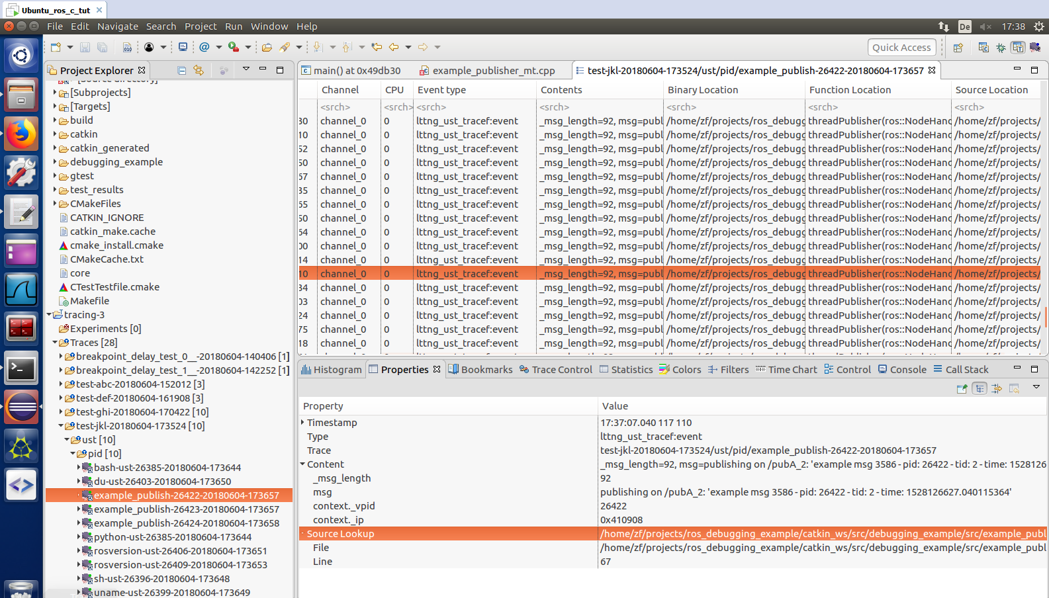

Figure 61 *Eclipse* Tracing Perspective - Table View

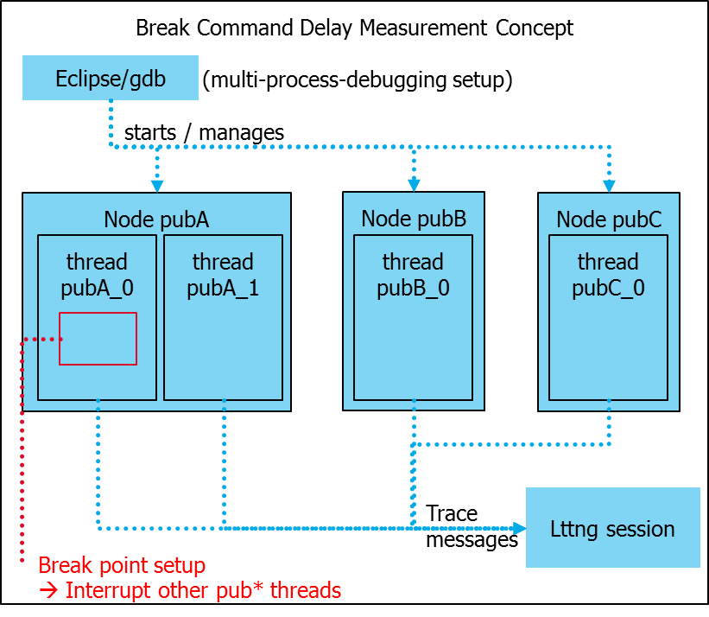

Figure 62 Concept to measure Break Command Delay

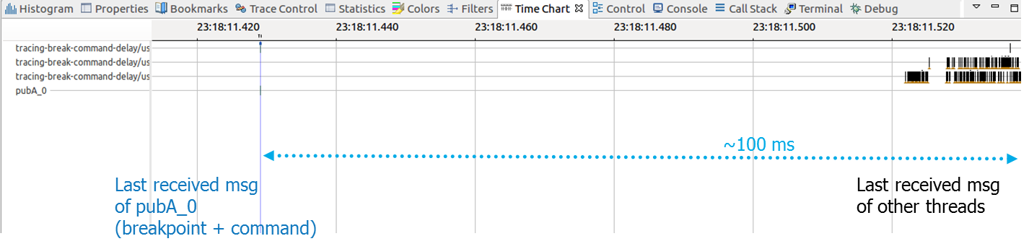

Figure 63 *Eclipse* Lttng Time Chart - Viewing Delay of Break Command – interrupt specific publisher threads

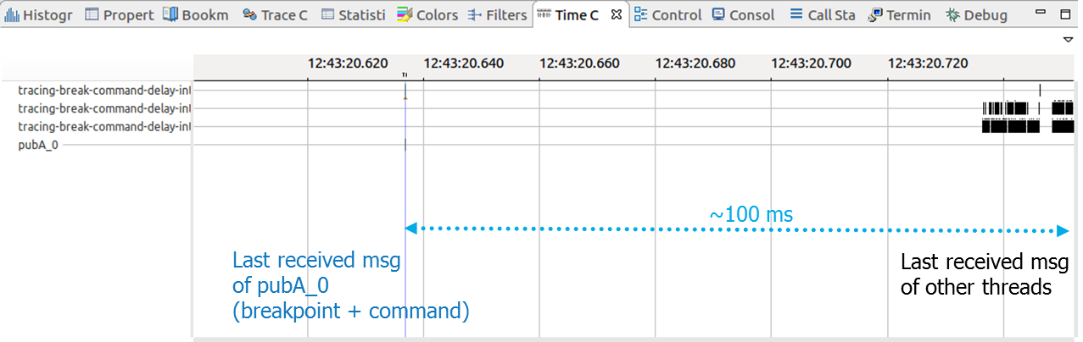

Figure 64 *Eclipse* Lttng Time Chart - Viewing Delay of Break Command - interupt all threads

# References

## Links

<https://www.eclipse.org/forums/index.php/t/338408/>

* How to debug forked processes

<https://www.eclipse.org/forums/index.php/t/172448/>

* Multi-Process debugging with DSF

<https://dirkraffel.com/2008/06/27/debugging-multiple-processes-with-eclipse-cdt/>

* Debugging multiple processes with *Eclipse* CDT

<http://wiki.eclipse.org/CDT/User/FAQ#How_do_I_use_multi-process_debugging.3F>

* How do I use multi-process debugging?

<https://sourceware.org/gdb/onlinedocs/gdb/Non_002dStop-Mode.html>

* 5.5.2 Non-Stop Mode

<http://wiki.eclipse.org/CDT/User/FAQ#I.27ve_been_asked_for_.27gdb_traces.27.2C_where_can_I_find_them.3F>

* Debugging C/C++ Projects

<http://wiki.eclipse.org/CDT/User/FAQ#Debugging_C.2FC.2B.2B_Projects>

* Debugging C/C++ Projects

<http://wiki.eclipse.org>

* -> FAQs -> C Development Tools FAQ -> Debugging C/C++ Projects

<https://answers.ros.org/question/10091/eclipse-debugging-in-ros/>

* Eclipse debugging in ROS

<http://wiki.ros.org/IDEs#Eclipse>

* experience of *Eclipse* and other IDEs

<http://wiki.ros.org/roslaunch/Tutorials/Roslaunch%20Nodes%20in%20Valgrind%20or%20GDB>

* How to Roslaunch Nodes in Valgrind or GDB
* How to obtain core dumps

<https://answers.ros.org/question/10043/how-do-i-start-a-launch-file-from-eclipse-ide/>

* How do I start a .launch file from *Eclipse* IDE

<http://wiki.ros.org/ROS/Tutorials/UsingRqtconsoleRoslaunch>

* tutorial for launch files

<http://wiki.ros.org/catkin/CMakeLists.txt#Installing_roslaunch_Files_or_Other_Resources>

* tutorial development of launch files

<https://answers.ros.org/question/51785/how-can-i-use-catkin-package-resources-with-the-devel-space/>

* launch files not automatically moved into devel space

<http://www.ceh-photo.de/blog/?p=899>

* Debugging ROS nodes started from launch file with *Eclipse*

<http://answers.ros.org/question/10043/how-do-i-start-a-launch-file-from-eclipse-ide/>

* roslaunch by external tools hook from *Eclipse*

<https://doc.lagout.org/security/2010_gdb.pdf>

* (5.4.5 Interrupted System Calls)

<https://sourceware.org/gdb/onlinedocs/gdb/Remote-Configuration.html>

* (20.4 Remote Configuration)

<https://sourceware.org/gdb/onlinedocs/gdb/Server.html>

* troubleshooting interrupted system call bug in ros_comm…

<https://answers.ros.org/question/67456/ros-qt-interrupted-system-call-on-plugin-startup/>

* troubleshooting interrupted system call bug in ros_comm …

<https://stackoverflow.com/questions/7763740/pyqt4-interrupted-system-call-while-calling-commands-getoutput-in-timer>

* troubleshooting interrupted system call bug in ros_comm …

<https://social.msdn.microsoft.com/Forums/en-US/555a916e-bf7d-450c-8e10-af0b84737b62/windows-bash-cant-debug-multithreaded-applications-with-gdb?forum=windbg>

* troubleshooting interrupted system call bug in ros_comm …

<http://ftp.gnu.org/gnu/gdb/gdb-8.1.tar.xz>

* build gdb from scratch

<http://wiki.ros.org/roslaunch>

* roslaunch

<http://wiki.ros.org/roslaunch/Commandline%20Tools>

* roslaunch commandline tools

<http://wiki.ros.org/roslaunch/Architecture>

* roslanch architecture

<https://ubuntuforums.org/showthread.php?t=979955>

* ssh

<https://help.ubuntu.com/lts/serverguide/openssh-server.html>

* install ssh server

<https://superuser.com/questions/467398/how-do-i-exit-a-ssh-connection>

* exit ssh connection (just type “exit”)

<http://wiki.ros.org/roslaunch/API%20Usage>

* python API for roslaunch (unstable)

<http://wiki.ros.org/sig/roslaunch>

* roslaunch new feature proposals

<http://wiki.ros.org/roslaunch/Tutorials/Roslaunch%20tips%20for%20larger%20projects>

* roslaunch example

<https://answers.ros.org/question/41413/how-to-include-a-launch-file-on-a-remote-machine-from-a-launch-file/?answer=41415#post-id-41415>

* include roslaunch file from other machine

<http://wiki.ros.org/roslaunch/XML/machine>

* roslaunch machine tags

<https://wiki.archlinux.org/index.php/SSH_keys>

* ssh keys

<https://answers.ros.org/question/244060/roslaunch-ssh-known_host-errors-cannot-launch-remote-nodes/>

* ROS has a flaw (feature?) in that it uses a library to so SSH, rather than the usual SSH client…

<https://answers.ros.org/question/243132/roslaunch-remote-pc/>

* ROSLAUNCH_SSH_UNKNOWN=1

<https://confluence.atlassian.com/bitbucketserver056/creating-ssh-keys-943528644.html?utm_campaign=in-app-help&utm_medium=in-app-help&locale=de_DE%2Cde&utm_source=stash>

* ssh-key for bitbucket for cloning

<https://stackoverflow.com/questions/1674162/how-to-handle-eintr-interrupted-system-call>

* another source how to handle interrupted system calls

<https://www.quora.com/What-are-interrupted-system-calls>

* what are interrupted system calls...

<https://www.linuxjournal.com/article/6100>

<https://www.linuxjournal.com/article/6210>

* ptrace and how it is used for system call interruption

<http://wiki.ros.org/pluginlib/Tutorials/Writing%20and%20Using%20a%20Simple%20Plugin>

* pluginlibTutorialsWriting and Using a Simple Plugin

<http://wiki.ros.org/nodelet>

* nodelet package

<http://wiki.ros.org/roscpp/Overview/Publishers%20and%20Subscribers#Intraprocess_Publishing>

* intraprocess no-copy pub/sub using shared pointers

<http://wiki.ros.org/nodelet/Tutorials>

* main nodelet tutorial site

<http://wiki.ros.org/nodelet/Tutorials/Running%20a%20nodelet>

* Running a nodelet

<http://wiki.ros.org/nodelet/Tutorials/Porting%20nodes%20to%20nodelets>

* Porting nodes to nodelets

<http://www.clearpathrobotics.com/assets/guides/ros/Nodelet%20Everything.html>

* ros::Timer callbacks instead of threads

<https://answers.ros.org/question/224698/what-causes-a-library-so-to-be-copied-to-devellib/>

* problem: .so files not built into devel/lib/<package>/lib<name>.so but into devel/lib/lib<name>.so
* result: intended

<http://wiki.eclipse.org/CDT/User/FAQ#Debugging_C.2FC.2B.2B_Projects>

* pretty-printing

<https://github.com/ros/ros_comm/issues>

* reporting issues about ros_comm

<https://sourceware.org/gdb/wiki/MultiProcess>

* multiprocess features of gdb and their integration in *Eclipse*

<https://stackoverflow.com/questions/5048112/use-gdb-to-debug-a-c-program-called-from-a-shell-script>

* gdb can not be used on shell scripts
* solution: use executable (i.e. python) and script (i.e. apc.py) as argument
* gdb --args bash <script>

<https://stackoverflow.com/questions/11255064/wait-for-gdb-to-attach>

* wait for gdb to attach?
* solution: infinite loop hack

<https://sourceware.org/gdb/onlinedocs/gdb/Server.html>

* gdbserver

<http://web.archive.org/web/20070915134947/http://www.mashebali.com:80/?Python_GDB_macros:Why_not_PDB%3F>

* pdb alternative using gdb

<https://wiki.python.org/moin/DebuggingWithGdb>

* debugging python with gdb

<https://sourceware.org/gdb/onlinedocs/gdb/Connecting.html#g_t_002d_002dmulti-Option-in-Types-of-Remote-Connnections>

* gdbserver –multi

<https://sourceware.org/gdb/onlinedocs/gdb>

* gdb documentation

<http://moss.cs.iit.edu/cs351/gdb-inferiors.html>

* gdb inferior tutorial

<http://student.itee.uq.edu.au/courses/csse2310/gdb-info/GDB_002fMI-Program-Execution.html>

* machine interface threads

<https://stackoverflow.com/questions/3183319/save-gdb-display-to-a-variable?rq=1>

* how to save info output into a variable???

<https://github.com/tromey/gdb/>

* multi-machine gdb (dead)

<https://stackoverflow.com/questions/25292587/multiple-remote-target-inferior-processes-in-gdb>

* Multiple remote target inferior processes in gdb
* Not possible atm

<https://stackoverflow.com/questions/46580386/gdb-server-how-do-you-attach-multiple-processes-from-multiple-machines>

* GDB Server - How do you attach multiple processes from multiple machines?
* Not possible atm

<https://stackoverflow.com/questions/32123041/launch-gdb-to-hook-onto-multiple-existing-processes-using-a-python-script?rq=1>

* Launch gdb to hook onto multiple existing processes (using a python script!)

<https://slideslive.com/38902683/the-gdb-bof-gdb-multitarget>

* Slides gdb multi-machine

<https://gcc.gnu.org/wiki/cauldron2017?action=AttachFile&do=get&target=GDB+%26+Multi-target.pdf>

* Slides gdb multi-machine

<http://gdb.sourceware.narkive.com/g33QmYwx/multiple-remote-inferiors>

* Gdb multi-remote-inferior

<https://www.roguewave.com/company/news/2013/european-academia-selects-totalview-debugger>

<http://docs.roguewave.com/totalview/current/pdfs/TotalView_for_HPC_Cheat_Sheet.pdf>

<https://www.roguewave.com/sites/rw/files/attachments/RW-TotalView-fnl-20170517.pdf>

* Totalview – commercial debugger – gdb alternative

<https://developers.redhat.com/blog/2017/11/10/gdb-python-api/>

* Gdb pretty printing example

<https://sourceware.org/ml/gdb/2012-12/msg00062.html>

* No tracepoint support in gdb python api

<https://bugs.eclipse.org/bugs/show_bug.cgi?id=394379>

* *Eclipse* bug, breakpoints remote

<https://answers.ros.org/question/12156/how-to-get-meaningful-backtraces-in-ros/>

* Backtrace from core files

<https://sigquit.wordpress.com/2009/03/13/the-core-pattern/>

* Core file name pattern

<https://www.nersc.gov/assets/Training/CS267/HPCTools-Gerber.pdf>

* DDT (gdb alternative)

<https://blog.regehr.org/archives/849>

* Book recommendations on general debugging strategy

<https://blog.regehr.org/archives/199>

* Debugging strategy / process

<https://lttng.org/docs/v2.10/>

* Tracing with lttng

[https://lttng.org/docs/v2.10/#doc-lttng-alternatives](https://lttng.org/docs/v2.10/)

* Tracing alternatives

<http://dmct.dorsal.polymtl.ca/sites/dmct.dorsal.polymtl.ca/files/Presentation.pdf>

* Tracing alternatives and comparisons

## Books & Papers

Only one book was reviewed so far:

* “Debugging” by David Agans